2020

South African GHG Emissions Reporting System (SAGERS) Frequently Asked Questions (FAQs)
SOUTH AFRICAN GREENHOUSE GAS EMISSIONS REPORTING SYSTEM (SAGERS) FREQUENTLY ASKED QUESTIONS
Version | Date | Created By | Reviewed By | Description
1.0 | Feb 2020 | M. Senatla Jaane | S. Mashele | Initial Version
2.0 | April 2020 | S. Mashele
3.0 | November 2020 | F.B. Moodley | S. Mashele
4.0 | February 2022 | S. Malaka | S. Mashele

Contents
1. General Questions 9
1.1. What is SAGERS? 9
1.2. Which is the recommended browser for accessing the SAGERS? 9
1.3. Do the NGERs within South Africa only use the IPCC Guidelines for instruction? 9
1.4. Is there a SAGERS user guide? 9
1.5. The report has been sent back for amendment however when I click on the edit icon the information disappears. I have tried using another browser and get the same result. 9
1.6. When my GHG report is generated on the dashboard, the reporting year states 2022, as below. Does this mean that I must report data for 2022? 10
2. Registration Questions 11
2.1. Will manual registration using the Annexure 2 form still be accepted going forward? 11
2.2. How does a public user register on SAGERS? 11
2.3. How does a data provider decide which IPCC Code is suitable to his/her facility? 14
2.4. I have selected an incorrect account type; how do I change the account type? 15
2.5. Can I link my SAAELIP account with my SAGERS account? 15
2.6. I registered for GHG reporting manually before December 2019 and have a Data Provider ID, how do I migrate to SAGERS? 15
2.7. I have standby generators; how do I register them in the system? 15
2.8. I have declared all my boilers and the system requires me to attach a document, what do I attach? 16
2.9. I have registered in the NAEIS; do I need to re-register on the SAGERS? 16
2.10. If a facility has not been required to report in terms of previous environmental-related legislation, will they still have to report via SAGERS? 16
2.11. I am a consultant and am failing to “Register New Data Provider” for my client 17
2.12. I just created a new account in SAGERS, but am failing to associate the consultant 17
2.13. I have submitted my registration form on SAGERS and would like to revise it, how do I modify my submission? 17
2.13.1. If the submission has not been approved by the authority, the ACO can request a revision/withdrawal by following the steps below: 17
2.13.2. If the submission has been approved by the authority, the ACO can submit a modification form by following the steps below: 19
2.14. I just registered on SAGERS and did not receive a data provider ID? 22
2.15. If a facility that has registered on SAGERS, ceases operations what are the steps that need to be followed to de-register on the system? Are there any additional notifications that need to be made? 22
2.16. What is the different between submittal ID and Data provider ID? 25
2.17. When I do the review step on the SAGERS – the data provider info is stated as missing and attachment flagged, what is required in the Attachment step? 25
2.18. How do I access proof of submittal? 25
2.19. How do I access GHG Reporting/ Registration Acceptance letters? 28
2.20. I am struggling with finalizing the Registration, I get an error message “server error in ’/ Ensuitutil.web’. application. 31
2.21. I am not sure which IPCC category my company triggers. What documents do I need to read and whom can I contact for assistance? 31
3. Application of Registration & Reporting Thresholds 32
3.1. Should a company include the LPG stove used in their staff kitchen in the GHG Data Provider Registration? 32
3.2. Do we consider rounding off in the application of thresholds, the data provider capacity is 9.916 MW? 32
3.3. If I have activities that meet reporting thresholds in my company and other activities that do not trigger the reporting threshold, do I have to register all activities? For example, stationary combustion installations that meet the threshold and waste treatment facility does not meet the reporting threshold. 32
3.4. How do I determine whether a company exceeds the 10 MW thermal net heat input, please confirm the equation to calculate the thermal net heat input for each item of stationary combustion equipment? 32
3.5. Do I include the Net Heat Input of backup stationary combustion installations in the total combined input, even though the installation has never been used/ is rarely ever used? 34
3.6. If the boilers are each below 10MWth, do they still need to be registered and reported on? 34
4. Reporting Questions 35
4.1. Are there any penalties for not reporting a facilities GHG emissions via SAGERS within the prescribed period? 35
4.2. What is the difference between a reporting period and a reporting cycle? 35
A “reporting period” is defined in the regulations as one calendar year. A reporting cycle is a term used purely internally by the DFFE. The reporting cycle numeration follows the reporting period by one, I.e. the reporting cycle 2025 would indicate the usage of data that was reported for the reporting period 2024. 35
4.3. How do I link a consultant to my profile to assist with reporting? 35
4.4. Circumstances determining the use of country-specific EFs and how this is dealt with inside SAGERS 37
Prepare and Submit Form 38
4.5. How do I convert the country specific net calorific values (NCVs) into the correct units for reporting? 39
4.6. Do the different Tier methods change the activity data that data providers need to report? 39
4.7. What information is required for Tier 3 submissions? 40
4.8. When using a Tier 3 method to estimate emissions, will a formal approval of the method used be issued to the data provider? 40
4.9. Do data providers need to use the AR3 to convert to CO_{2eq} instead of the more recent ARs? 41
4.10. When do we use Notation keys when reporting on SAGERS? 41
4.11. Are we able to choose different Tier methods on SAGERS for different fuels when reporting? 41
4.12. Is the GHG Report linked to the registration of the company? 41
4.13. Do I still need to report after I have deregistered the Data Provider/ facility during the previous reporting cycle? 41
4.14. Can I deregister a data provider/facility after an executive decision has been made to no longer operate the plant? 42
4.15. When reporting emissions from the IPPU Sector Metal Industry, do I need to report emissions from secondary production of metals? 42
4.16. When reporting on fugitive emissions from mining, what activity data is expected in the GHG Report when asked for “Amount of coal produced”, does this mean the Run of Mine (ROM) of the coal sold. 42
5. Technical Questions 42
5.1. Are there any other sequestration guidelines that may be applicable to unmanaged forest land? 42
5.2. Do the fruit tree plantations fall within the definition of “Forest”, could they be considered Forest land? 43
5.3. Do we report emissions from fires on Temporary unplanted areas? 43
5.4. If the company exceeds the threshold, but the wastewater treated is inorganic in nature so does not contain carbon and so would not result in GHG emissions then does the company need to register for this activity or not? 43
5.5. When reporting on the SAGERS system are emissions from mobile combustion (emissions from vehicles) as well as emissions from purchased electricity still excluded from reporting? 43
5.6. Can EPA Method 3C be used for sampling of CO₂ & CH₄ from coal-fired boiler for the purposes of GHG reporting on SAGERS? 44
5.7. A foundry produces iron castings, aluminium, zinc, brass and bronze. The aluminium gets melted and casted, they do not add anodes to their process. 44
5.7.1. Should the foundry register for 2C3 - Aluminium production? 44
5.7.2. If 2C3 Aluminium production should be excluded, should we still report on the HFO fuel combusted when melting the Aluminium? 44
5.8. Does a foundry casting steel, iron, etc. using an induction furnace have to register and report GHG emissions? 44
5.9. Treatment of emissions from secondary steel production when electric arc furnaces are used. 45
5.10. I am using non- carbonaceous clay with an insignificant carbon content to manufacture bricks do I need to report process emissions? 45
5.12. Recycled oil is used in our production process, what calorific value and emission factors should be used when reporting on this fuel? 46
5.13. We I received analyses for my coal from a laboratory. Which value should I use for the NCV: “As Received”, “Air Dried” or “Dried”? 46
5.14. Which value must be used for NCV: higher heating value (or Gross Calorific Value - GCV) or lower heating value (or Net Calorific Value - NCV)? 46
5.15. A client of ours burns waste tyres as part of the production process. From the National Treasury Budget 2021, we gather that this is exempt from carbon tax for this year as there are no emission factors available (see attached on page 151). 46
5.17. Will the SA Emission Factors be published in time for the March 2023 GHG reporting cycle? Or can I assume that we’ll need to use Tier 3, mass balance, etc. methods where “Tier 2 or 3” is stipulated in the Regulations? 47
5.18. Can I report my GHG emissions using the 2019 IPCC Refinements? 47
5.19. Emissions from Fishing Vessels 47

Abbreviations
ACO | Accounting Officer
DFFE | Department of Forestry, Fisheries and the Environment
ECO | Environmental Control Officer
GHG | Greenhouse Gas
IPCC | Intergovernmental Panel on Climate Change
NAEIS | National Atmospheric Emission Inventory System
NEMA | National Environmental Management Act
NGERs | National Greenhouse Gas Emissions Reporting Regulations
SAAELIP | South African Atmospheric Emission Licensing and Inventory Portal
SAGERS | South African Greenhouse Gas Emissions Reporting System

Definitions
ACO | The Accounting Officer (ACO) serves as a primary user for the data provider and is responsible for certifying and submitting submittals on behalf of his/her Data Provider on the SAGERS. An ACO can also assign ECO/Consultants to help prepare the submittals for each facility that the ECOs/Consultants are assigned to.
ECO | Secondary user for the data provider is nominated by the ACO to help prepare submittals for each specific facility. The ECOs/Consultants can only prepare submittals and cannot submit them.
Consultant | Third party user contracted by the data provider, is nominated by the ACO to help prepare submittals for each specific facility. The consultant can only prepare submittals and cannot submit them
Public User | Means a user on the SAGERS, with the ACO, ECO or Consultant designation.
Submittal I.D. | This is the number is used to track submittals on the SAGERS, in the registration process it can be used to track the status of the registration submission in SAGERS before it is approved.
Data Provider I.D. | This is the reference number that is generated when the registration submission is approved in SAGERS. The number serves as a unique identifier for each data provider registered on the SAGERS.

General Questions

What is SAGERS?
The South African Greenhouse Gas Emissions Reporting System (SAGERS) is the Greenhouse Gas (GHG) reporting module of the National Atmospheric Emission Inventory System (NAEIS). Data providers that conduct activities and meet the reporting thresholds specified in Annexure 1 of the National GHG Emissions Reporting Regulations (NGERs), 2016 and amendments thereof, are required to register and report on the SAGERS.

Which is the recommended browser for accessing the SAGERS?
Google Chrome is the recommended internet browser for the SAGERS Portal.

Do the NGERs within South Africa only use the IPCC Guidelines for instruction?
In developing the NGERs, South Africa not only considered the IPCC guidelines but also other factors. For example, the Intergovernmental Panel on Climate Change (IPCC) guidelines do not prescribe the reporting approach and do not provide guidance on the use of thresholds for national reporting. Therefore, at best, the IPCC guidelines help us with methodological guidance.

South Africa have made several changes in other areas that are not consistent with the IPCC guidelines, such as the treatment of combustion emissions from brick manufacturing, production of synthetic fuels from coal and gas operations.

Is there a SAGERS user guide?
Yes, there is a user guide available on the SAGERS landing page. You may access the landing page by following link below:
https://ghgreporting-public.environment.gov.za/GHGLanding/SAGERSHome.html

The report has been sent back for amendment however when I click on the edit icon the information disappears. I have tried using another browser and get the same result.
Please click on the small key on the address bar, delete all saved passwords and then refresh your SAGERS page.
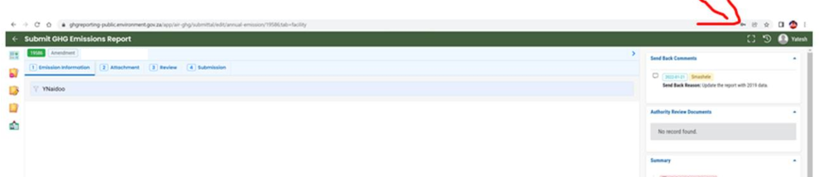

When my GHG report is generated on the dashboard, the reporting year states 2022, as below. Does this mean that I must report data for 2022?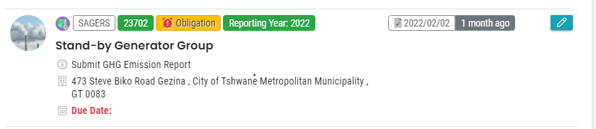
No. The reporting year means the year in which you are submitting your report. Therefore, in the above case, you will be submitting your GHG Report by 31 March 2022.
However, the information submitted will be for the reporting period 01 January 2021 to 31 December 2021. The reporting period means the preceding year to the reporting year. Please refer to question 4.2 for clarity.

Registration Questions

Will manual registration using the Annexure 2 form still be accepted going forward?
The Annexure 2 form will no longer be accepted as a form of registration. Facilities will need to go onto the following website and register on the SAGERS Portal. The Annexure 2 form is now a part of the online portal.
https://ghgreporting-public.environment.gov.za/pub/login

How does a public user register on SAGERS?
Step 1: The public user will need to follow the below link to the SAGERS website
https://ghgreporting-public.environment.gov.za/GHGLanding/SAGERSHome.html
Once here, the public user should click on the login button (within the red square) located under the “Public Portal (Production)” section.
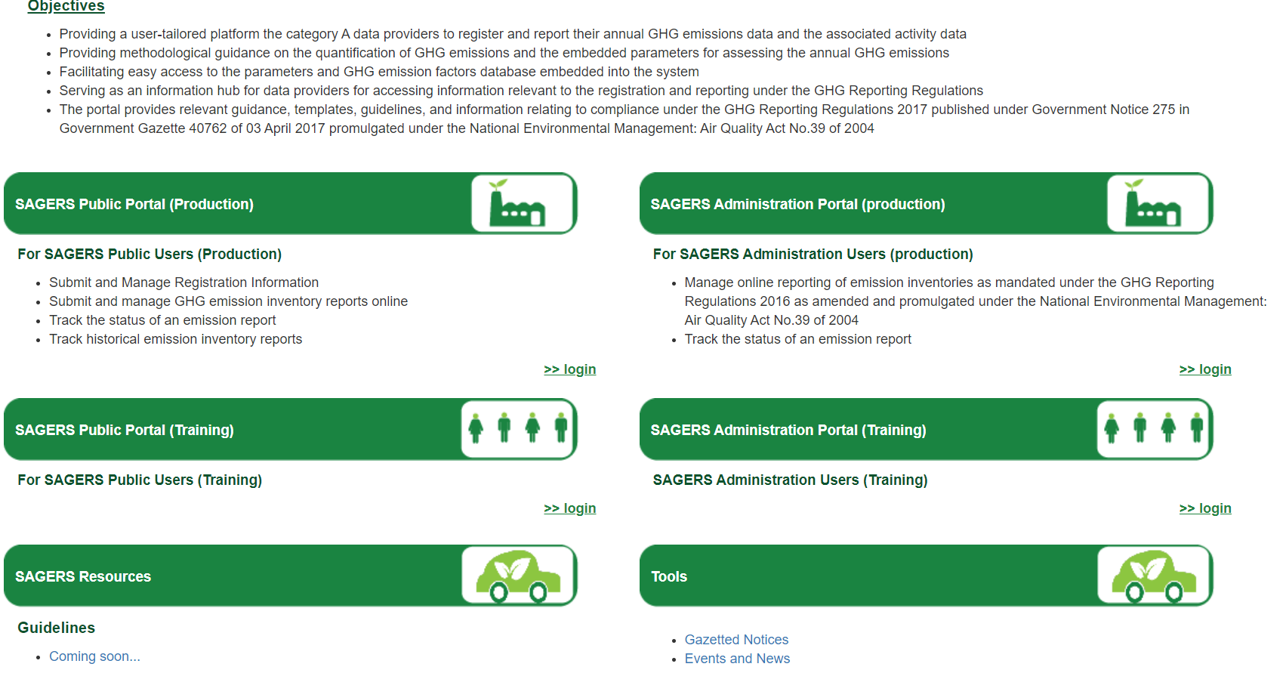
Step 2: The below page will open in your browser.
The public user should then click on “Register Account”.
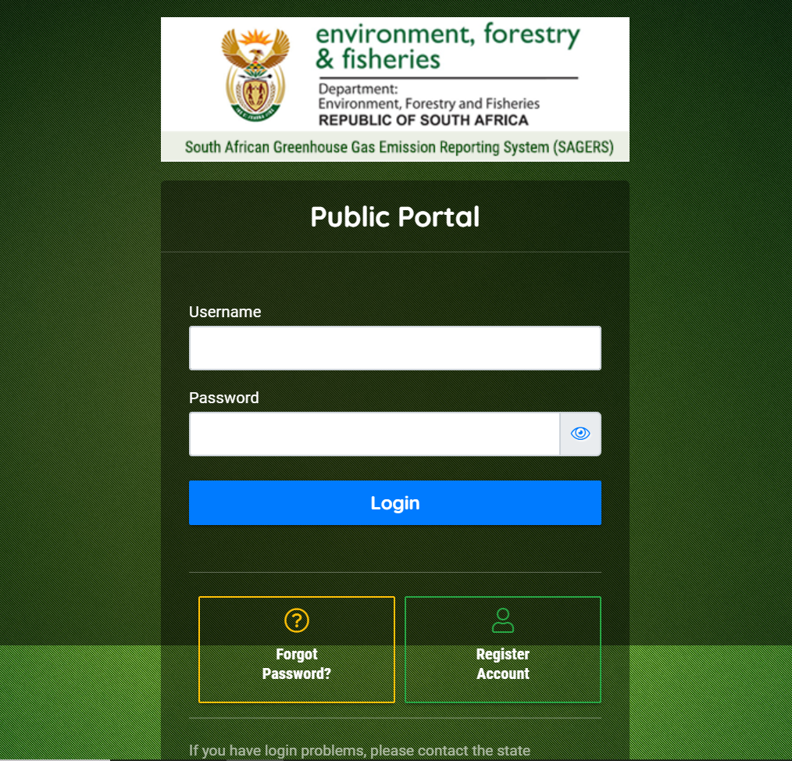
Step 3: The following tab will open once the data provider clicks on “Register Account”.
The public user will need to fill his/her personal information shown in the two (2) images below before clicking on “Next” to move to the next tab.
A username (used to log onto the site in future) will be created, by the system, based on your first and last names. Note that you may change your username on this form before moving onto the next tab.
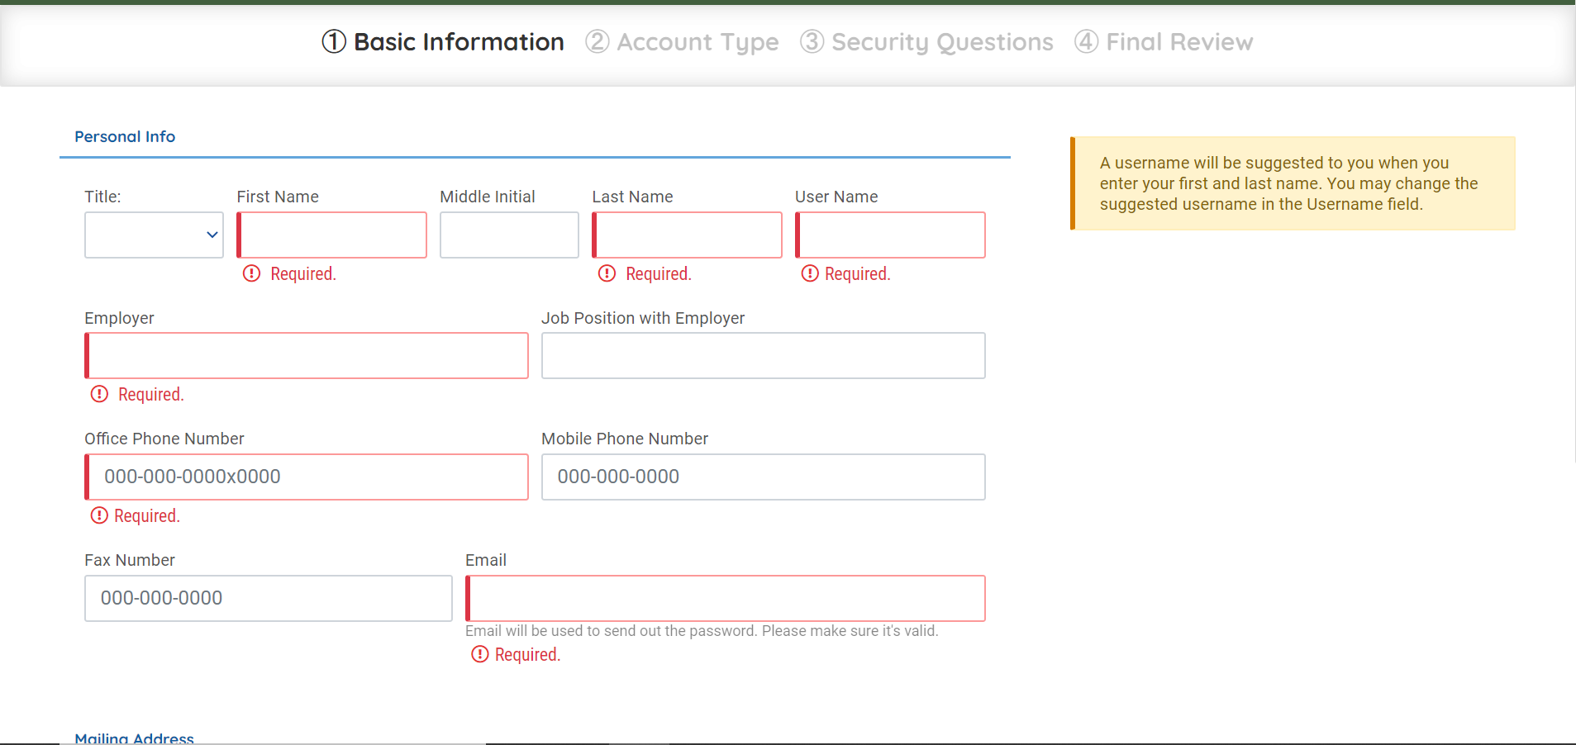
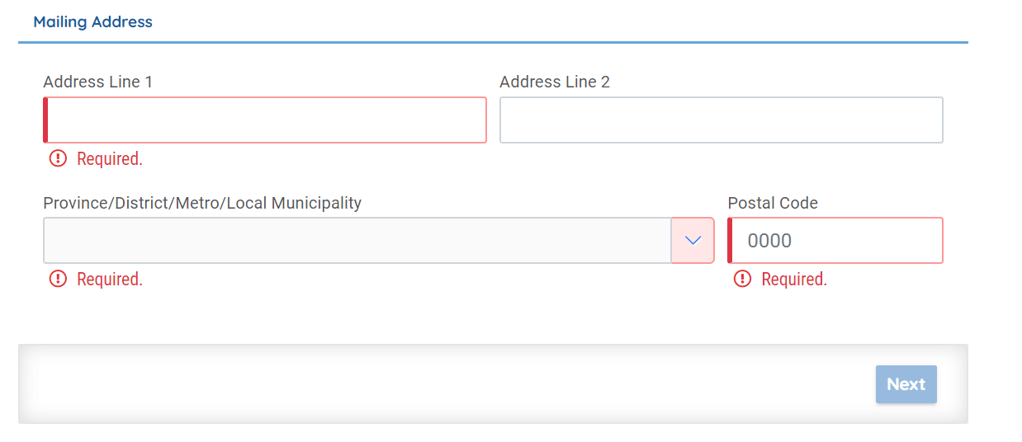
Step 4: The next tab allows you to choose your account type.
You may choose either ACO, ECO/Consultant or Other. The public user will need to choose the relevant account type before moving to the next tab. See account type definitions above.
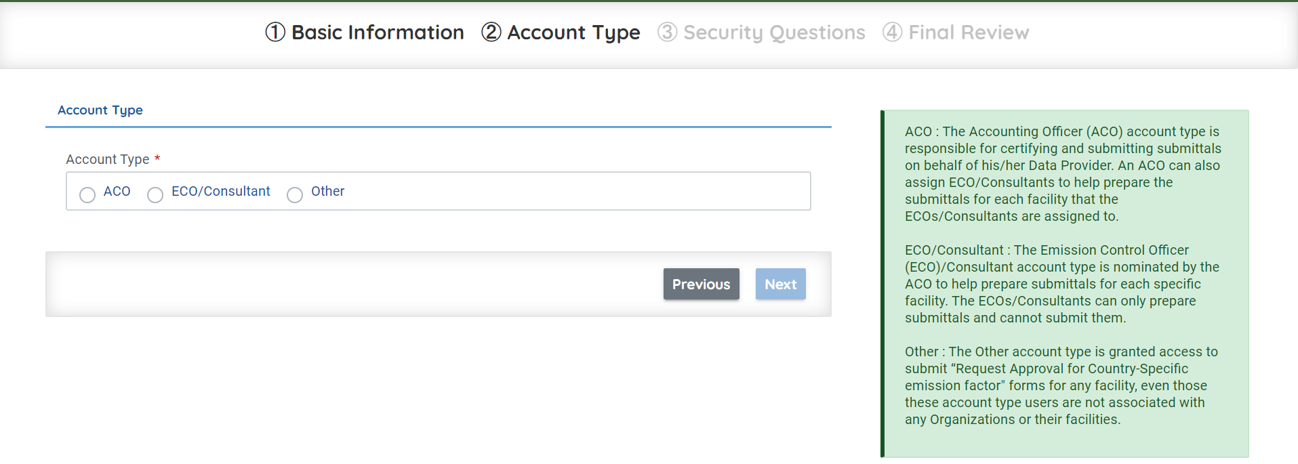
Step 5: The data provider will then need to choose five (5) security questions from the drop-down menu and provide answers to them.
These security questions and answers will need to be remembered for future submissions.
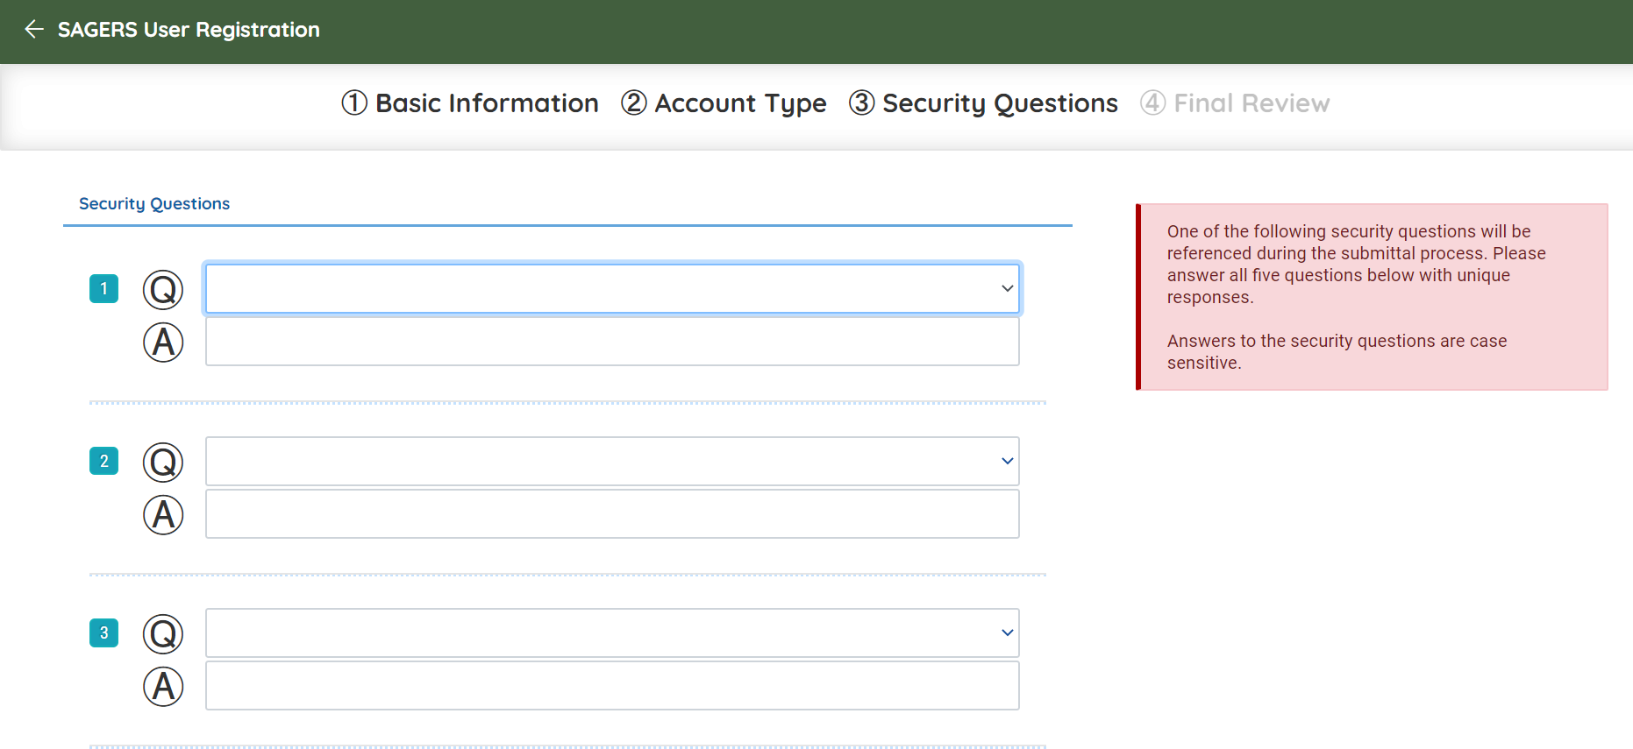
Step 6: The final tab allows you to review your personal information and then register.
Once you click on register an email will be sent to you with your password allowing you to log onto the SAGERS Portal again. A pin will also be sent to you which the data provider will use to submit documents along with the security question answers. Both the password and pin can be changed on the system once you login.

How does a data provider decide which IPCC Code is suitable to his/her facility?
The data provider will be required to go through the NGERs, 2016 including amendments to the regulations as well as the Methodological Guidelines for Monitoring, Reporting and Verification of Greenhouse Gas Emissions by Industry. The documents can be found by following the links below:
- Greenhouse Gas Emission Reporting Regulations, 2017
https://www.environment.gov.za/sites/default/files/legislations/nemaqa39of2004_nationalgreenhousegasemissionreporting_gn40762_0.pdf

- Greenhouse Gas Emission Reporting Regulations, 2017 Amendments

https://www.environment.gov.za/sites/default/files/legislations/nemaqa_greenhousegasemissions_reportingregulationamendment_g43712gon994.pdf

- Technical Guidelines
https://www.environment.gov.za/sites/default/files/legislations/technicalguidelinesformrvofemissionsbyindustry_0.pdf

I have selected an incorrect account type; how do I change the account type?
The SAGERS Portal does not allow users to change their account type because of data integrity. Many permission settings are built based on a specific account type. Therefore, a public user needs to register a new account in the SAGERS Portal using the correct account type.
Please contact to us on ghgreporting@environment.gov.za in order to deactivate your current account before you re-register.

Can I link my SAAELIP account with my SAGERS account?
The South African Atmospheric Emission Licensing and Inventory Portal (SAAELIP) and SAGERS cannot be linked as they are setup to achieve two separate regulations that have not been harmonized currently, therefore data providers are required to register separately under SAGERS.

I registered for GHG reporting manually before December 2019 and have a Data Provider ID, how do I migrate to SAGERS?
Data providers that had registered manually using the Annexure 2 form, can use a transfer code provided by the Department of Forestry, Fisheries and the Environment (DFFE) to transfer their registration information on the SAGERS.
DFFE has provided transfer codes to those existing data providers to update their information. It must be noted that IPCC activities must be updated as this information is missing on the information transferred in the SAGERS.
If your company did not receive a transfer code from DFFE, please send an email to ghgreporting@dffe.gov.za to request your transfer code by providing the name of your company and your data provider ID.

I have standby generators; how do I register them in the system?
Standby generators can be reported as one (1) aggregated facility group if they are used under one (1) IPCC code. Each Standby Generator group must be linked to the relevant IPCC activity.
For example, if you have generators that are used to generate electricity for lighting and general office use during load shedding periods or when you don’t have electricity for any particular reason, you will need to report all those generators under one (1) facility using the relevant IPCC code. That is, if the generator is used in food processing industry the IPCC code that needs to be used is, 1A2e: Food Processing, Beverages and Tobacco. The capacity of the aggregated facility will be the total capacity of the individual generators.
Additional to this entry in SAGERS, data providers are required to fill in and attach the stand-by generator inventory sheet found under SAGERS Resources under Guidelines on the landing page. The inventory sheet should include all stand-by generators used by the data provider. Please follow the link below to the landing page:
https://ghgreporting-public.environment.gov.za/GHGLanding/Docs/Standby%20generators.xlsx

I have declared all my boilers and the system requires me to attach a document, what do I attach?
If you register more than 1 boiler in SAGERS (as shown in Figure below), the system will require you to attach a spreadsheet that includes the list of all the boilers you have.
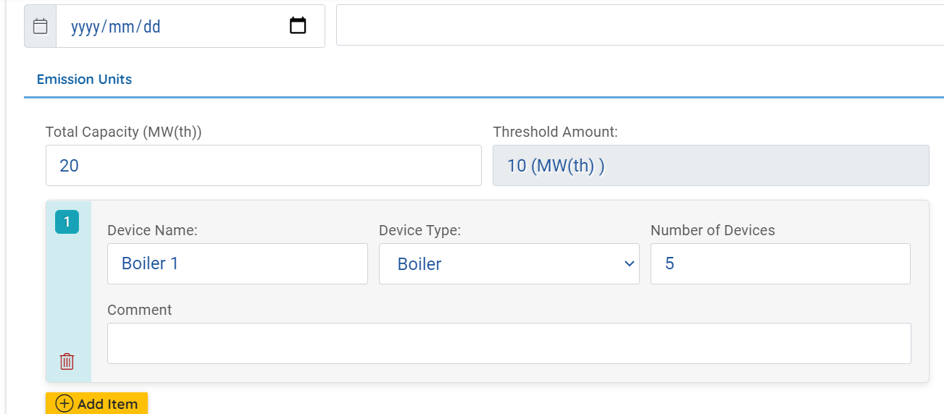
The template to include these boilers is found on the landing page under Templates:
https://ghgreporting-public.environment.gov.za/GHGLanding/SAGERSHome.html
The template also allows the data providers to calculate their installed boiler capacity, by following steps detailed in the template.

I have registered in the NAEIS; do I need to re-register on the SAGERS?
The SAGERS is the GHG reporting module of the NAEIS, however due to the different reporting requirements with the original NAEIS, the registration is not directly linked.
Data providers that meet the reporting thresholds in Annexure 1 of the NGERs, 2016 are required to register and declare their activities on SAGERS.

If a facility has not been required to report in terms of previous environmental-related legislation, will they still have to report via SAGERS?
Yes, a facility will need to report their GHG emissions via SAGERS if they meet the reporting thresholds as per the NGERs, 2016 and any amendments thereof.

I am a consultant and am failing to “Register New Data Provider” for my client
For the “Register New Data Provider Form,” we do not allow ECOs/consultants to submit a registration form since the data provider does not exist in the system until DFFE approves the “Register New Data Provider Form”. Therefore, the “Register New Data Provider Form” can only be initiated by the ACO of the facility/facilities, and once approved the ACO can associate an ECO/Consultant to the facility.
ECOs/Consultants can only help the data provider to prepare the “Modification Form”, “De-registration Form” and “GHG Annual Emission Report.”

I just created a new account in SAGERS, but am failing to associate the consultant
The ACO should have an approved data provider registration submittal on the SAGERS before they can associate an ECO/Consultant to assist them with preparation of an annual emission report and other submittals on SAGERS.

I have submitted my registration form on SAGERS and would like to revise it, how do I modify my submission?

If the submission has not been approved by the authority, the ACO can request a revision/withdrawal by following the steps below:
Step 1: Once on the dashboard, click on the “Track Submittal Status” tab on the left navigation pane
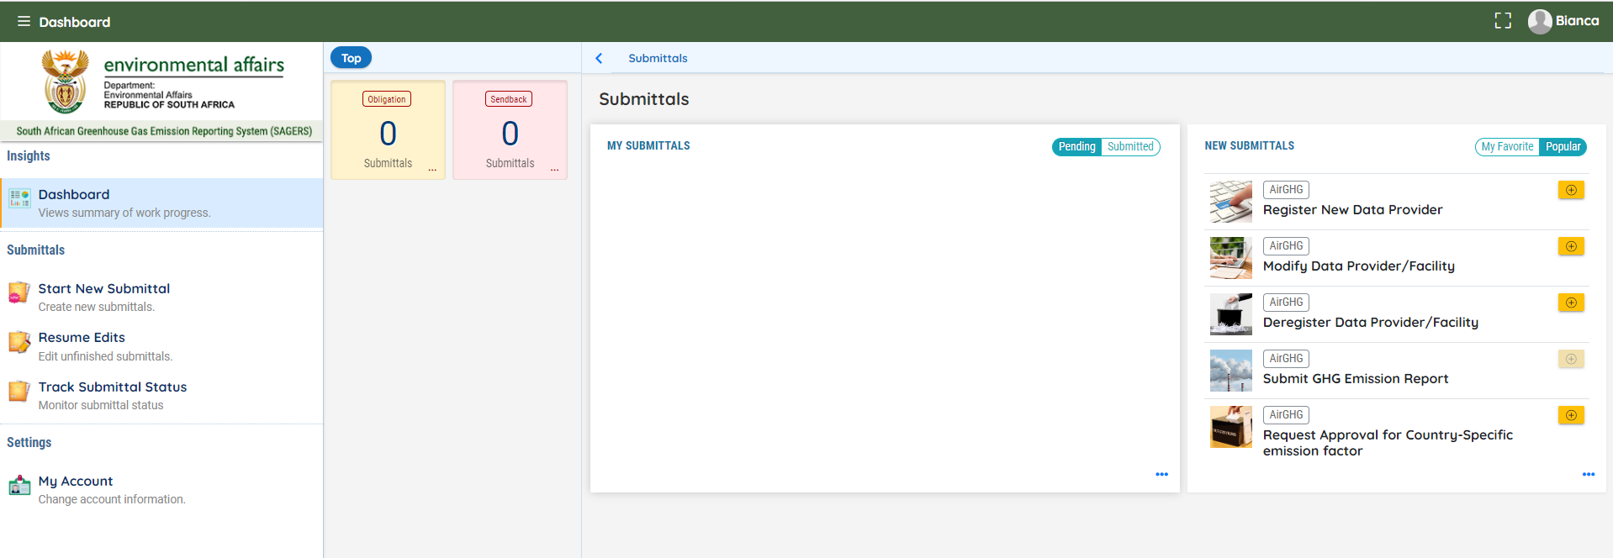
Step 2: Then click on the orange icon found on the right of the facility you wish to revise/withdraw the report.
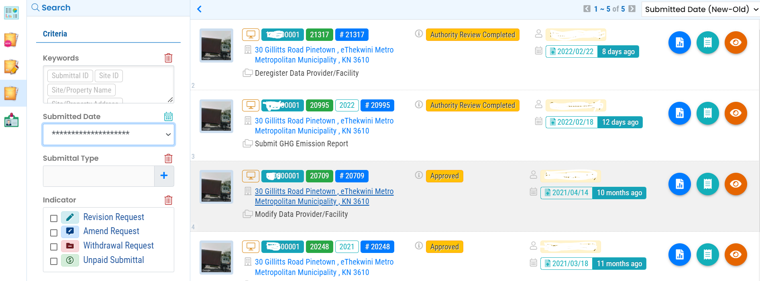
Step 3: Click on the “Send the request for Revision/Withdrawal to the administrator” tab at the top of the screen
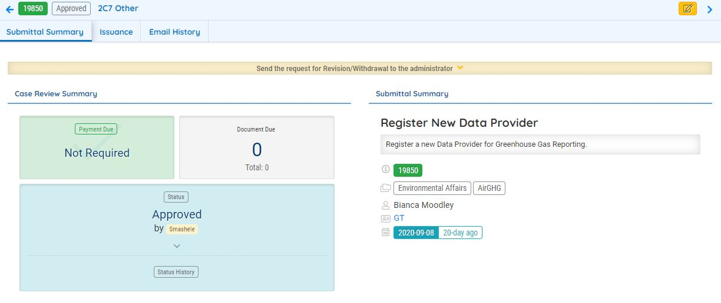
Step 4: Click on either “Revision” or “Withdrawal” and complete the box requesting a reason for the modification. Once completed, you may click on the “Send Request”
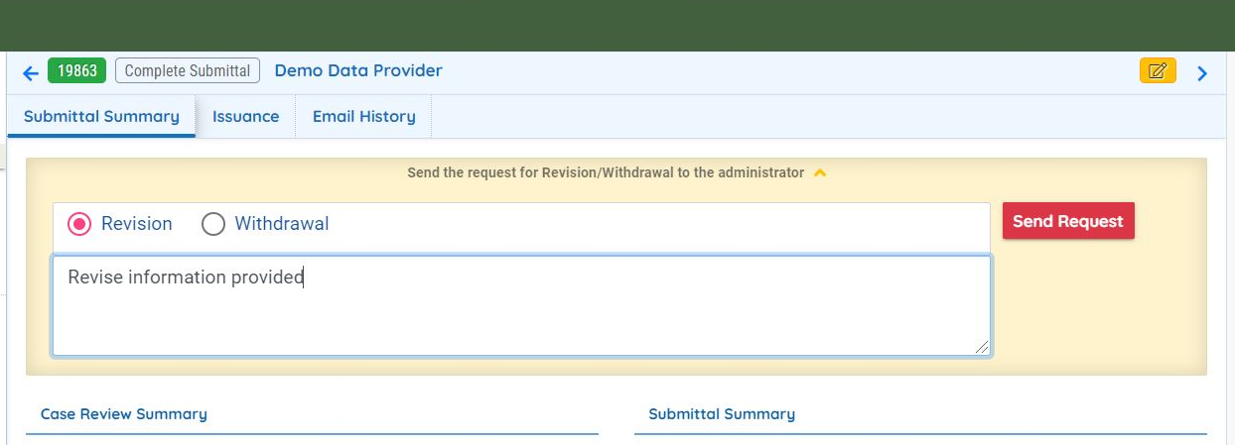
After sending the request, you wait for the approval from the administrator.

If the submission has been approved by the authority, the ACO can submit a modification form by following the steps below:
Step 1: On the dashboard, click on the “Start New Submittal” tab found on the left navigation pane or “Modify Data Provider/Facility” tab found on the right navigation pane.
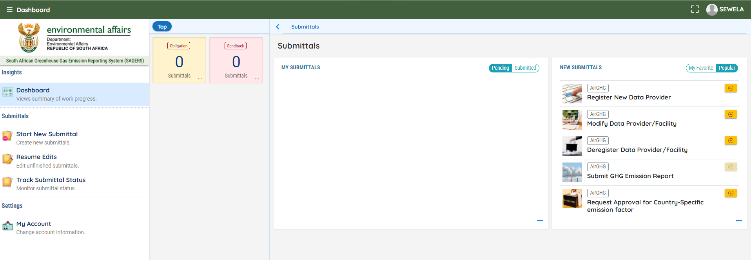
Step 2: Prepare and Submit Modify Data Provider/Facility Form
Step 2.1: Pick associated data provider
Public users need to select the data provider which they want to modify from the Data Provider dropdown field. In this field, the system will display active data provider records which are registered under the current public user’s account with SAGERS. After selecting the relevant data provider, the system will automatically populate the currently approved registration information of this data provider.
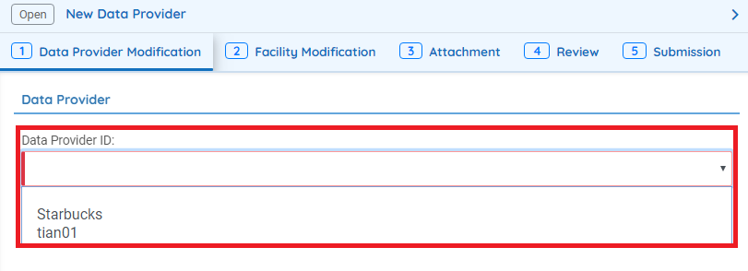
Step 2.2: Modify Registration Information
The public user is then able to directly update the attested information of the data provider based on populated records.
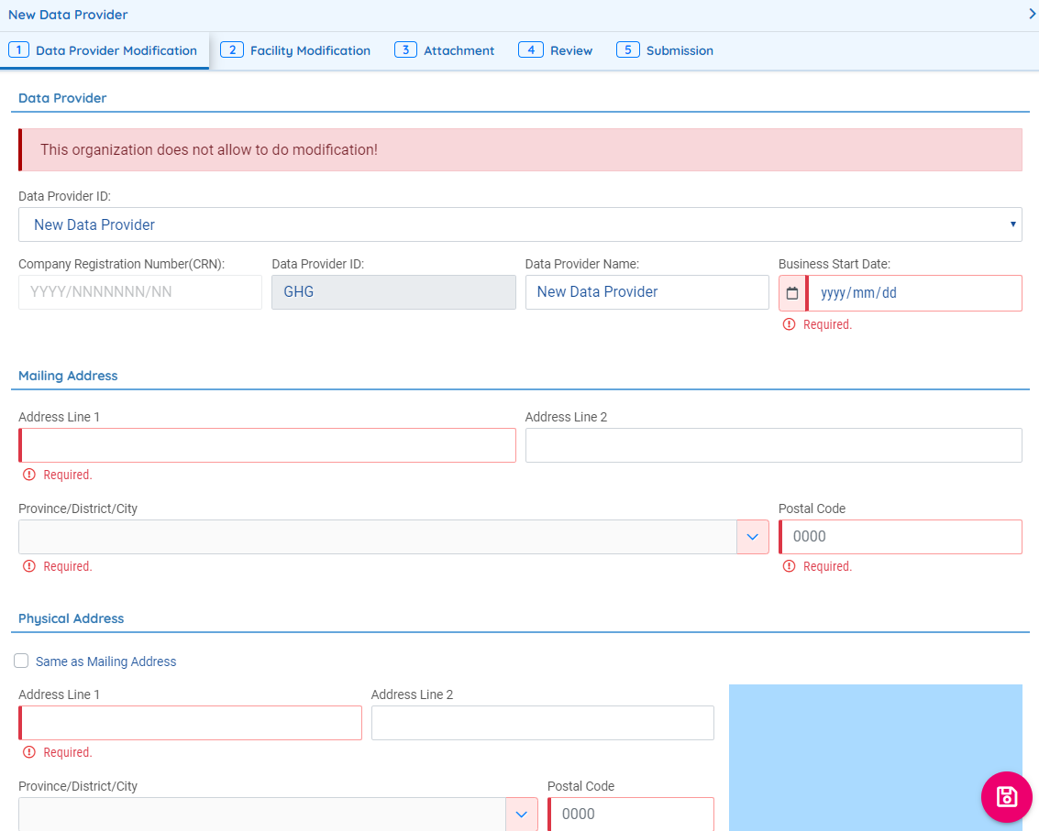
Under the “Facility Modification” tab, public users may add or link a facility
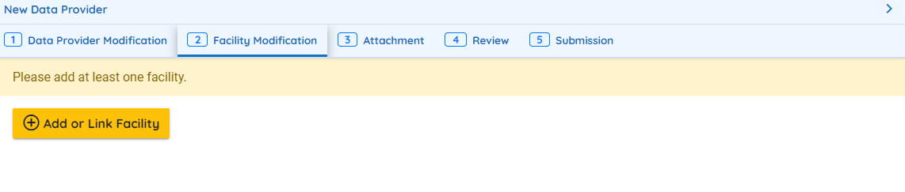
Once the above step has been completed the data provider may edit the current information captured for the data provider such as the and activity information for any of the facilities.
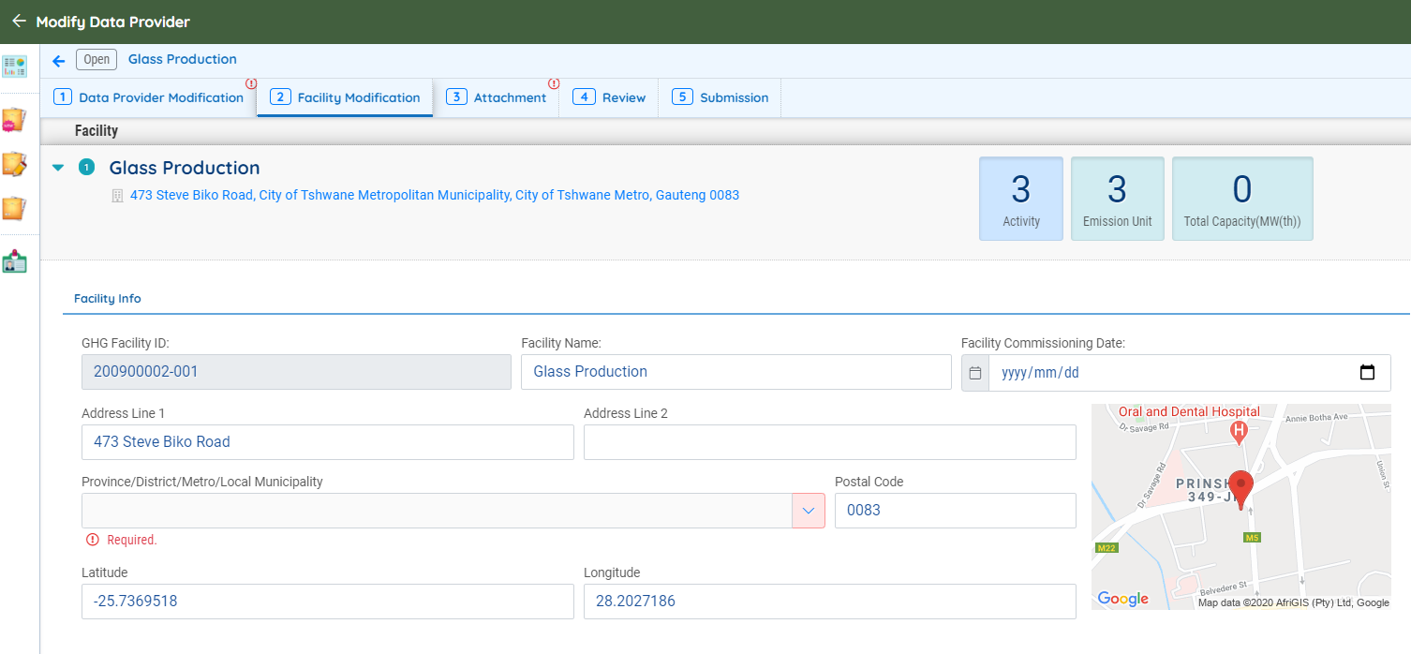
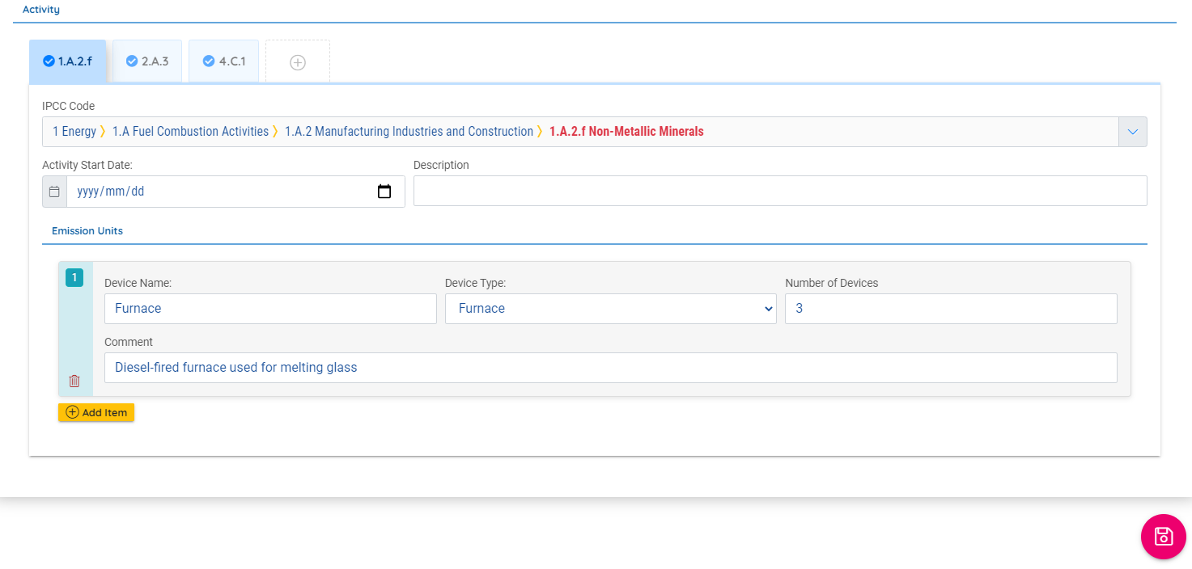
Step 3: Public users may then upload any relevant attachments and then review the form and submit. Please note that evidence should be provided for the addition or removal of facilities or activities conducted at the facilities.

I just registered on SAGERS and did not receive a data provider ID?
The data provider ID only becomes available once you have an approved data provider registration on the SAGERS Portal. The data provider ID is included with the approval letter issued on the system.

If a facility that has registered on SAGERS, ceases operations what are the steps that need to be followed to de-register on the system? Are there any additional notifications that need to be made?
Step 1: The data provider will need to log into his/her account.
Once the data provider is on the dashboard, click on Deregister Data Provider on the right navigation pane, as shown below:
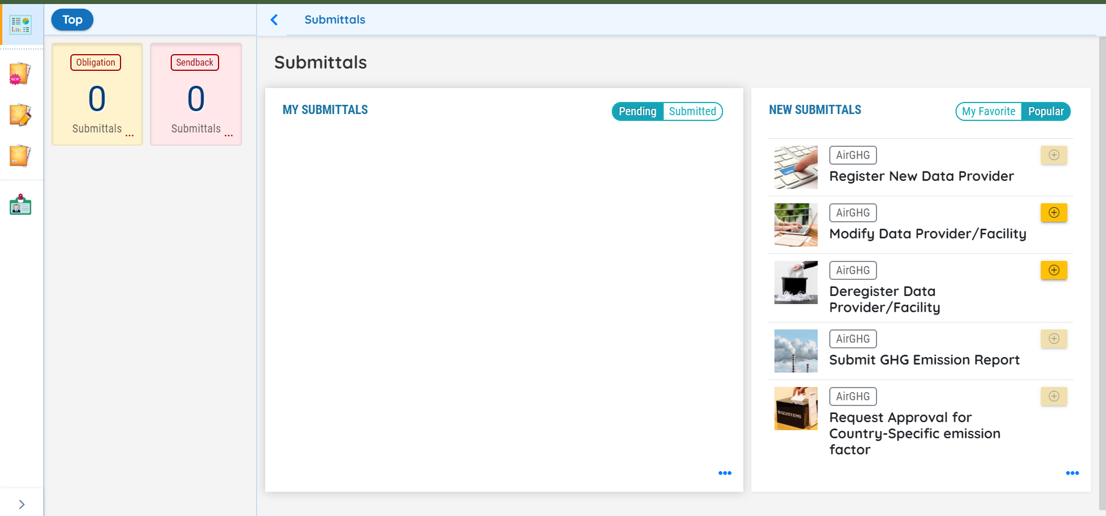
Step 2: Select the Data Provider Name from the drop-down menu, fill in the company registration number and commissioning date, if these do not automatically appear below.
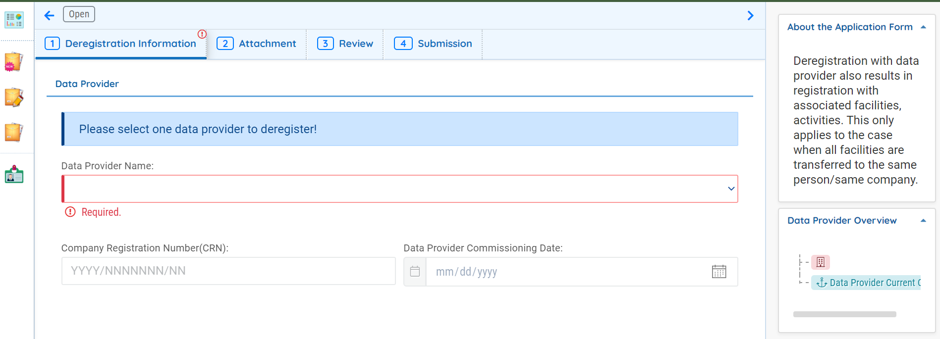
Step 3: Once the information under the Deregistration Information tab has been completed, the data provider can move to the Attachment tab. Here the data provider will need to attach a letter from the accounting officer as to the reason for the company closing.
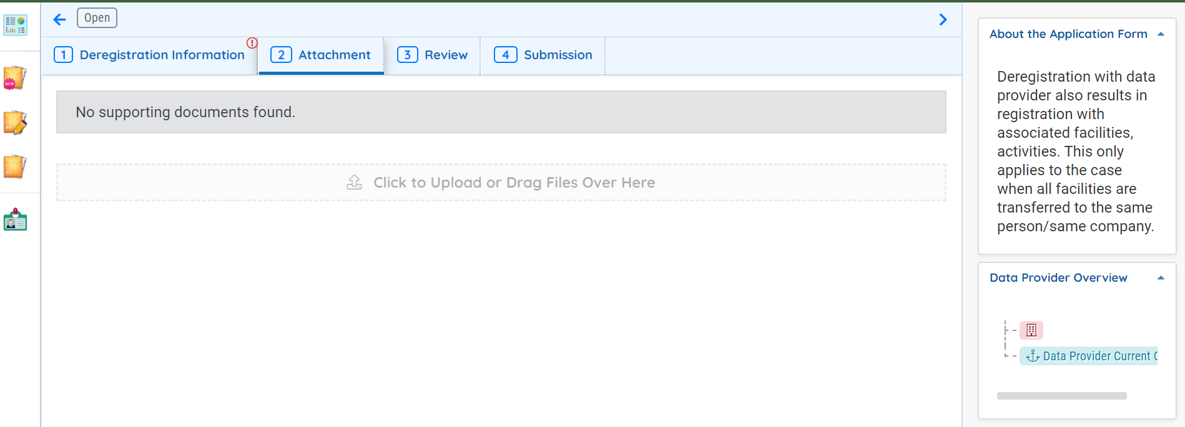
Step 4: Once the letter has been attached, the data provider may review the information provided and then submit the online form. You will be required to input a security question answer and pin before you can submit.
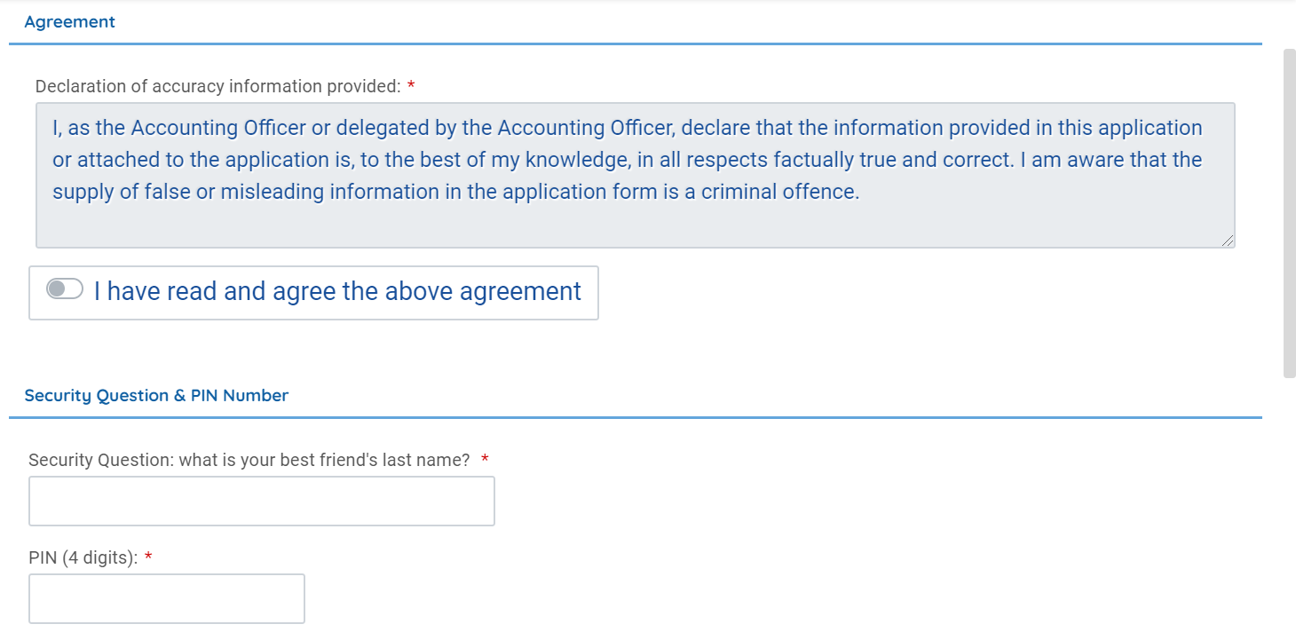
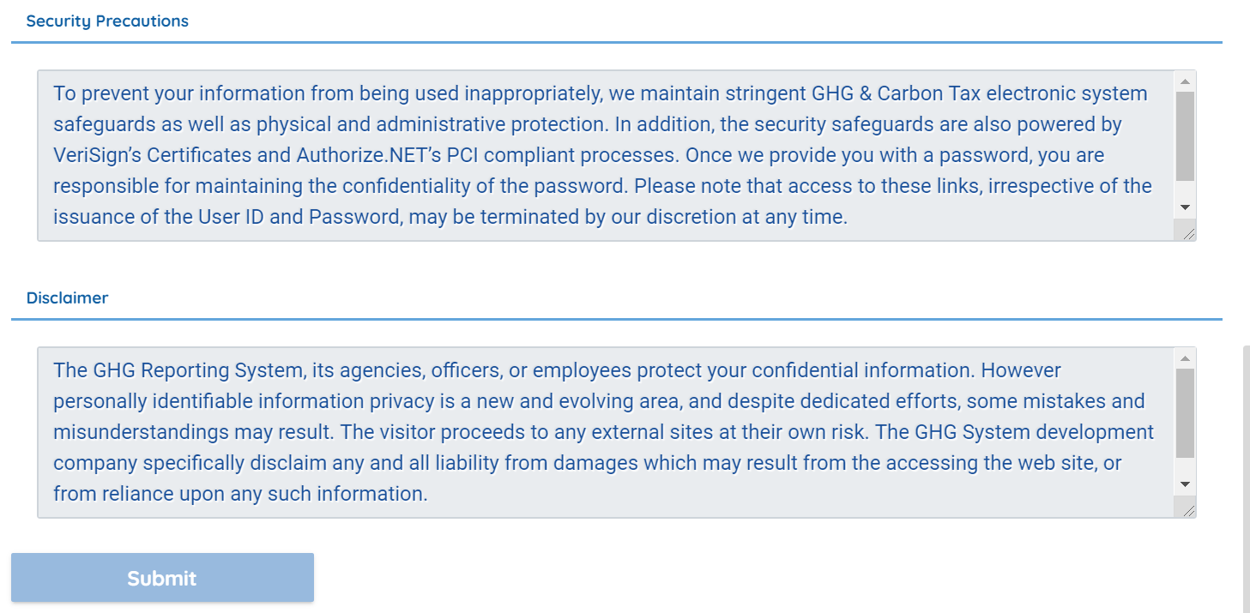

What is the different between submittal ID and Data provider ID?
Submittal ID: is the number used to track submittals on the SAGERS. In the registration process it can be used to track the status of the registration submission in SAGERS before it is approved.
Data Provider ID: is the reference number that is generated when the registration submission is approved in SAGERS. This number serves as a unique identifier for each data provider

When I do the review step on the SAGERS – the data provider info is stated as missing and attachment flagged, what is required in the Attachment step?
If you have registered a back-up generator, you will need to attach a list of all back-up generators that are owned by the data provider using the template found by following the link below:
https://ghgreportingpublic.environment.gov.za/GHGlanding/Docs/Standby%20generators.xlsx

How do I access proof of submittal?
Step 1: On the dashboard, click on the “Track submittal status” tab found on the left navigation pane
Step 2: Once the page opens, click on the blue button on the right of the facility you require the summary report
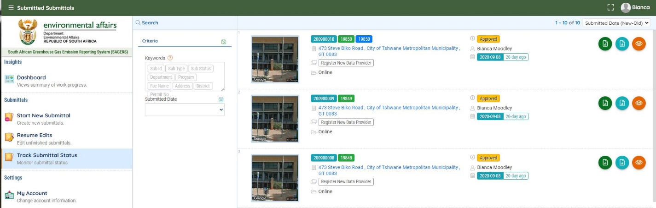
Step 3: Once the report opens up, click on the “Receipt” tab. A pdf appears, which you can download and save.
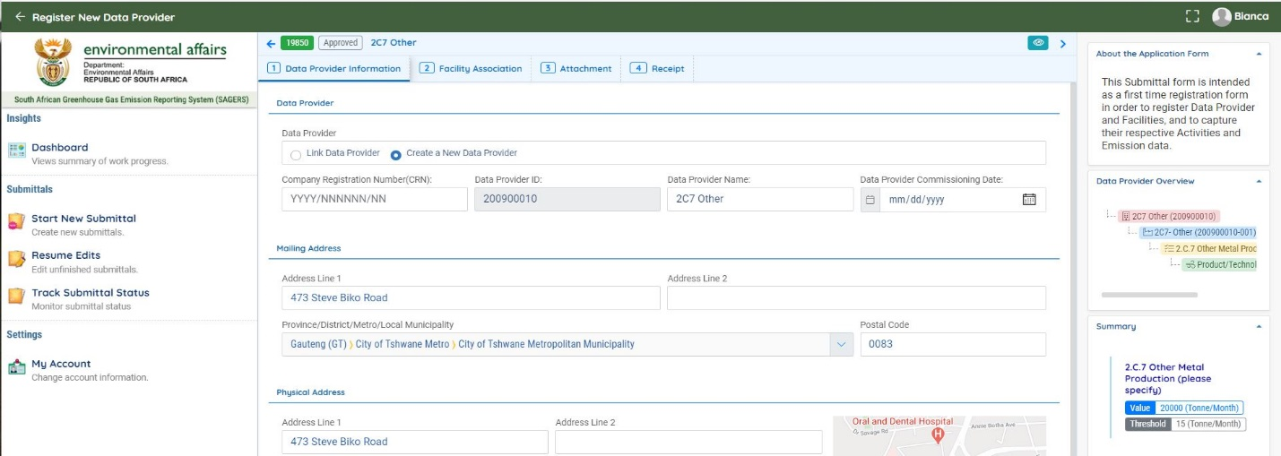

Step 4: Below is an example of the “Submittal Receipt”
You may download and save the submittal receipt for your records.
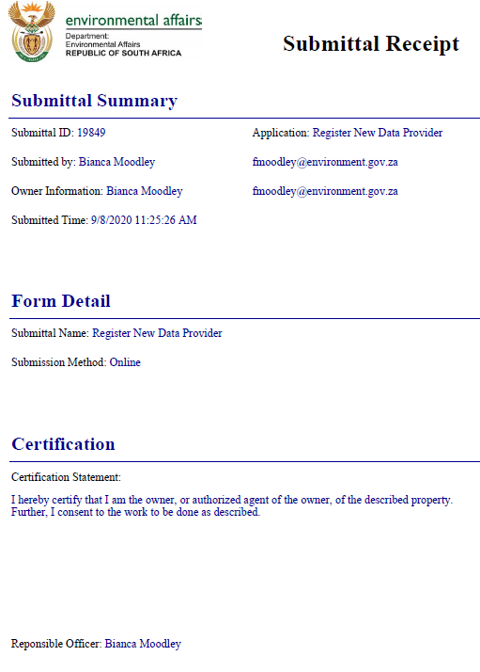

How do I access GHG Reporting/ Registration Acceptance letters?
Step 1: On the dashboard, click on the “Track submittal status” tab found on the left navigation pane
Step 2: Once the page opens, click on the orange button on the right of the facility you require the summary report
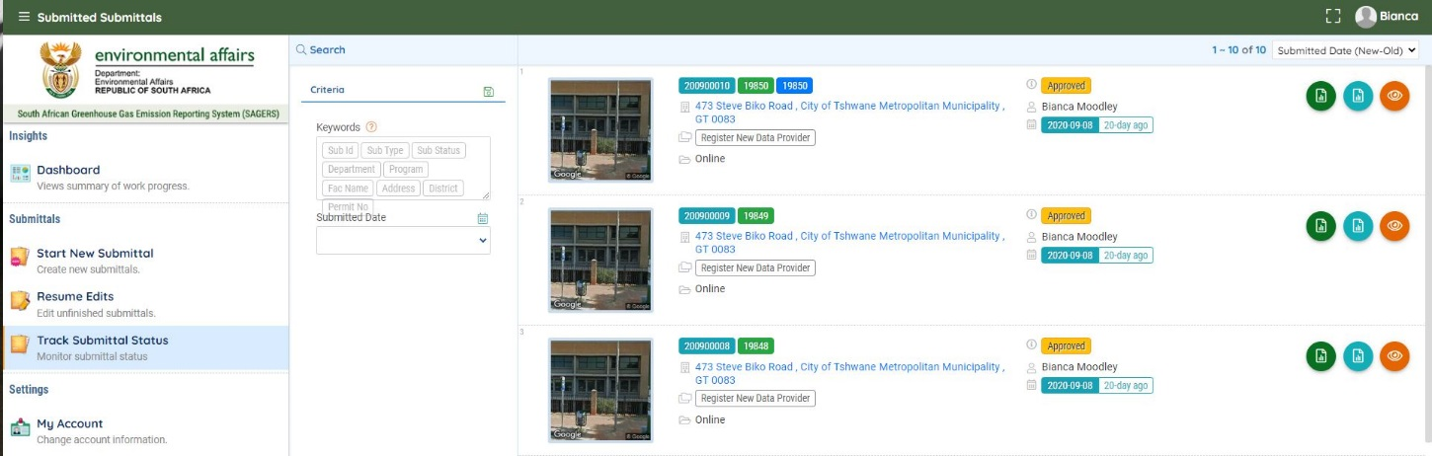
Step 3: Once the report opens up, click on the “Issuance” tab. A pdf appears, which you can download and save.
Note: The issuance letter will only be available once your report has been approved.
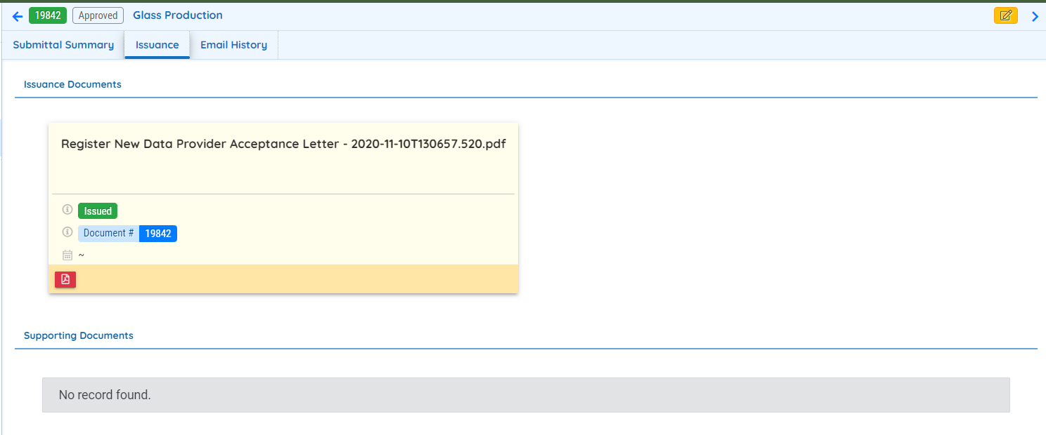
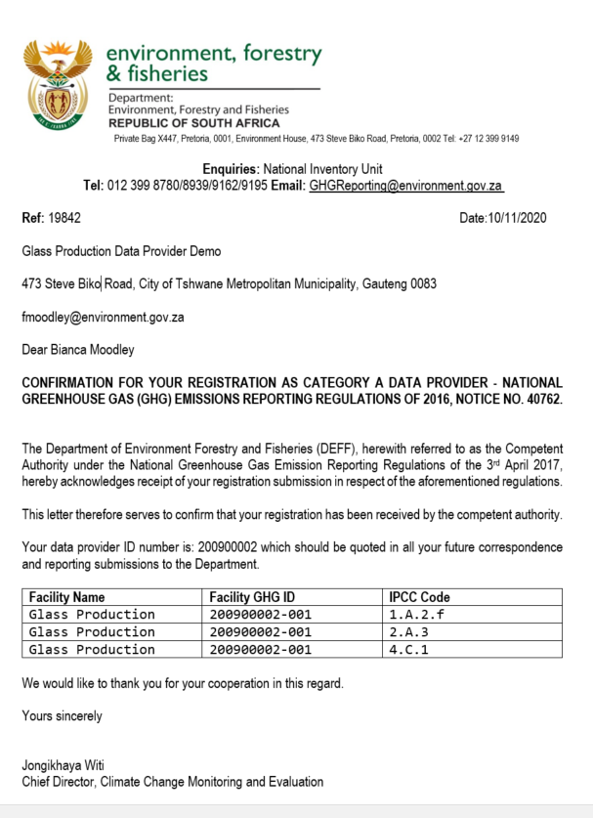

I am struggling with finalizing the Registration, I get an error message “server error in ’/ Ensuitutil.web’. application.
Currently the system only supports .za and .com domain names. Other unique domain names are not supported at the moment.
Google Chrome is the recommended internet browser for the SAGERS.

I am not sure which IPCC category my company triggers. What documents do I need to read and whom can I contact for assistance?
Data providers may read the following documents for further clarity on IPCC categories:
- 2016 National GHG emission reporting regulations - https://www.gov.za/documents/national-environmental-management-air-quality-act-regulations-national-greenhouse-gas-3
- 2006 IPCC Guidelines - https://www.ipcc-nggip.iges.or.jp/public/2006gl/
- 2019 IPCC Refinements - https://www.ipcc-nggip.iges.or.jp/public/2006gl/
Should data providers require further assistance, please contact the GHG Inventory and Systems Directorate on GHGReporting@dffe.gov.za

3. Application of Registration & Reporting Thresholds

Should a company include the LPG stove used in their staff kitchen in the GHG Data Provider Registration?
If the LPG stove is in company premises and the company has operational control over such a device, and they meet the reporting threshold they will have to register the stove.

Do we consider rounding off in the application of thresholds, the data provider capacity is 9.916 MW?
The reality is that the actual capacity does not equal or exceed the threshold and therefore this entity should not be subject to registration.

If I have activities that meet reporting thresholds in my company and other activities that do not trigger the reporting threshold, do I have to register all activities? For example, stationary combustion installations that meet the threshold and waste treatment facility does not meet the reporting threshold.
No, the data provider should only register the activities that meet or exceed the thresholds provided in Annexure 1 of the NGERs, 2016 and any amendments to the Regulations there of. In cases of stationary combustion, the cumulative threshold of all combustion installations in all facilities under the operational control of the data provider must be considered when determining the applicable threshold.

How do I determine whether a company exceeds the 10 MW thermal net heat input, please confirm the equation to calculate the thermal net heat input for each item of stationary combustion equipment?
Since the thermal input power (MW (th)) for internal combustion engines cannot be found on the data-plate or information supplied by the manufacturer it would need to be calculated. There are various ways that the thermal input power can be calculated, however, we have detailed a few ways below. Please consider the following methodologies to estimate the MW (th) for your installed equipment:
- Output based approach

Approach A:
MW (th) = $P_{r} ×100/e_{e}$

MW (th) is the megawatt thermal (in MW)
P_{r} is the rated power (MW) (mechanical or electrical, whichever is available)
e_{e} is the effective efficiency (%) relevant for mechanical or electrical power.
The effective efficiencies are presented in Table 1 below.

Approach B: - boiler design steam output

$$MW\left(th\right)=\frac{S*h_{s,i}*\left(1+\frac{L}{100}\right)}{1000}$$

MW (th) is the megawatt thermal (in MW)
S is steam output in (kg/s)
h_{s,i} is the enthalpy of steam at absolute pressure I (kJ/kg)
L is the thermal loss of the system as a percentage
1 000 is used to convert kW (i.e. kJ/s) to MW

- Input based approach

$MW \left(th\right)=m_{F}×NCV$ [1]

MW (th) is the megawatt thermal (in MW)
m_{F} is the fuel consumption or gravimetric fuel rate (in kg/s). Value used should be the design input fuel rate, as per the design specifications, and not actual usage.
NCV is the Net calorific value (in MJ/kg)

- Standby generator units

Uses output based methodology. Since MW (th) is a mechanical rating, one has to find the electrical rating first and then calculate the mechanical rating.

Calculating electrical power rating

Since the capacity of most standby generators are given in kilovolts Ampere (kVA), use the power factor you know for your network/load. If you don’t know your own power factor, use 0.8 as a default power factor. Use Equation [2] to calculate the rated electrical power:

$P_{e(r)}=power factor×kVA$ [2]

Where $P_{e(r)}$ is the Rated electrical power (kW), power factor is 0.8 and kVA is the kilovolt Amperes rating.
Then this electrical power ( $P_{e(r)}$) must be converted to mechanical power to take account of efficiency and Equation [3] is used
$P_{MW(th)}=\frac{P_{e(r)}×{100}/{η_{e} }}{1 000}$ [3]
Where $P_{MW(th)}$ is Megawatt thermal input (MW (th)) and $η_{e}$ is the efficiency (%).

Table 1: Effective efficiencies
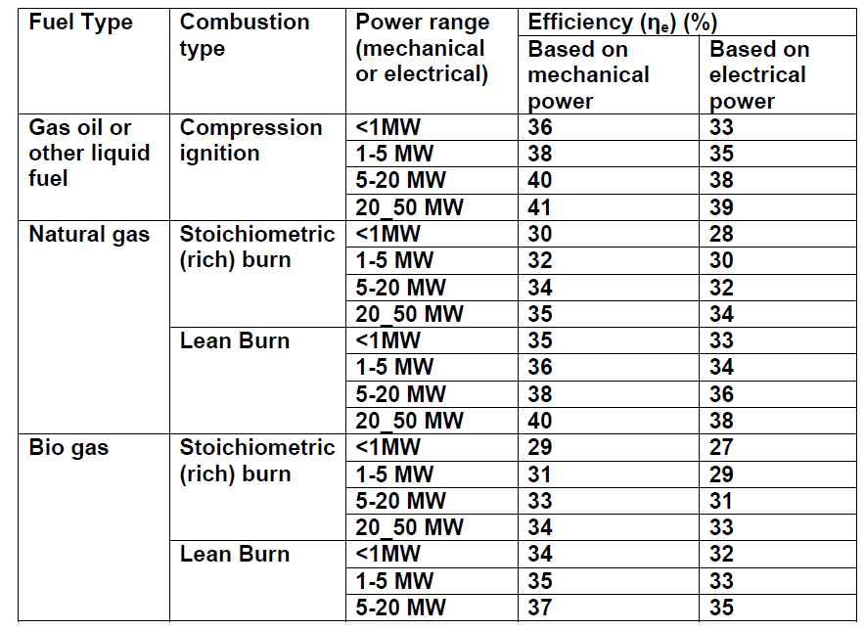

Do I include the Net Heat Input of backup stationary combustion installations in the total combined input, even though the installation has never been used/ is rarely ever used?
Yes. The NGERs require that all combustion installations that are present must be considered when determining the combined Net Heat Input for the facility or Data Provider.

3.6. If the boilers are each below 10MWth, do they still need to be registered and reported on?
The threshold is applicable at a Data provider level not at facility level. This is the sum of all installed capacities. As a data provider you have to register and report activities under your operational control as mandated by the National Greenhouse Gas (GHG) Emissions Reporting Regulations of 3rd April 2017, Notice No. 40762. Category A: any person in control of or conducting an activity marked in the Category A column above the capacity given in the threshold column of the table in Annexure 1 to these Regulations. “Operational control” means a data provider has operational control or another company if it, or one of its subsidiaries, has the full authority to introduce and implement its operating policies at the company.

Reporting Questions

Are there any penalties for not reporting a facilities GHG emissions via SAGERS within the prescribed period?
Non-compliance is always enforceable as per the National Environment Management Act (NEMA), 1998, however there is no timeframe given for such enforcement to happen, and it does not expire. As per the NGERs, the following penalties applies to non-conformance:
A person convicted of an offence in terms of regulation 16 of these Regulations is liable in the case of a first conviction to a fine not exceeding R5 million or to imprisonment for a period not exceeding five years and in the case of a second or subsequent conviction to a fine not exceeding R10 million or imprisonment for a period not exceeding 10 years and in respect of both instances to both such fine and such imprisonment.

What is the difference between a reporting period and a reporting cycle?

A “reporting period” is defined in the regulations as one calendar year. A reporting cycle is a term used purely internally by the DFFE. The reporting cycle numeration follows the reporting period by one, I.e. the reporting cycle 2025 would indicate the usage of data that was reported for the reporting period 2024.

How do I link a consultant to my profile to assist with reporting?
Step 1: On the dashboard, click on the “My Account” tab found on the left navigation pane
Step 2: Click on the “Consultant” at the top of the screen
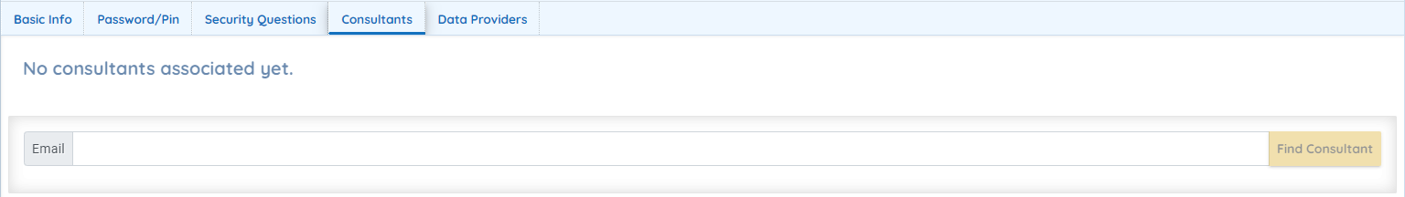
Step 3: Insert the email address of the consultant you want to associate and click on the “Find Consultant” button
It’s important to note that the consultant needs to have registered on the SAGERS Portal before you search for their email address, as their information needs to be a part of the SAGERS database
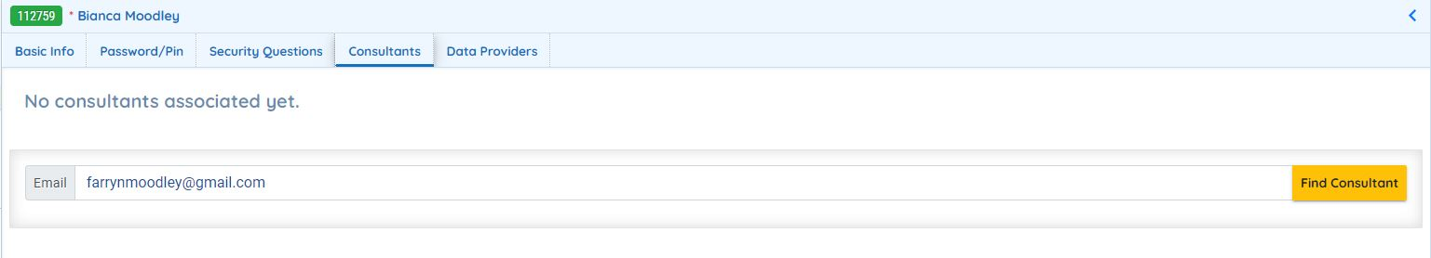
Step 4: Click on the “Link” button
Once you click on the “Link” button, the consultant is associated
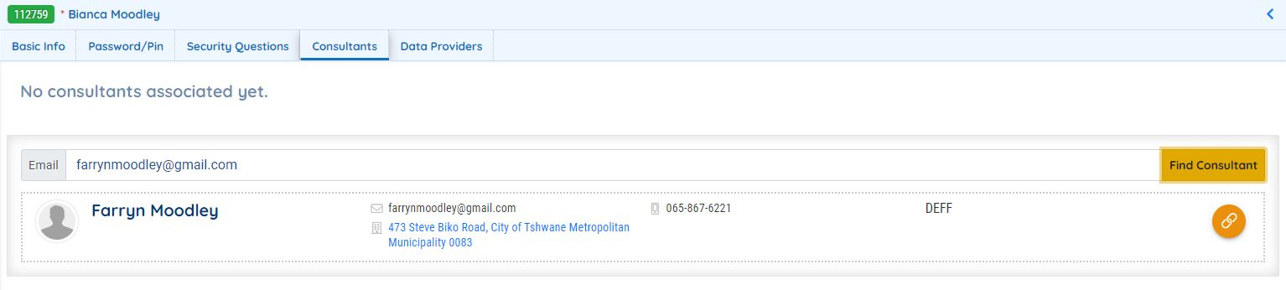
Step 5: Click on the drop-down to provide permissions to the consultant
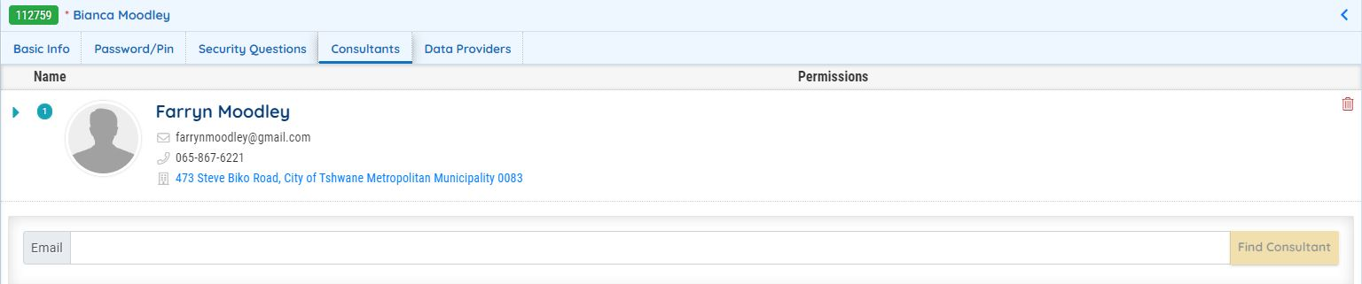
Step 6: Fill in the drop-down
Under Data Provider and Submittal, choose the Facility you require assistance with and the type of assistance, such as report preparation, modification or de-registration.
Under Permission, choose whether you want the consultant to assist with preparation or just be able to view the report.
Once you have decided on the effective and expiration dates of the permissions, you may click on the “Permission” button and then “Save”.
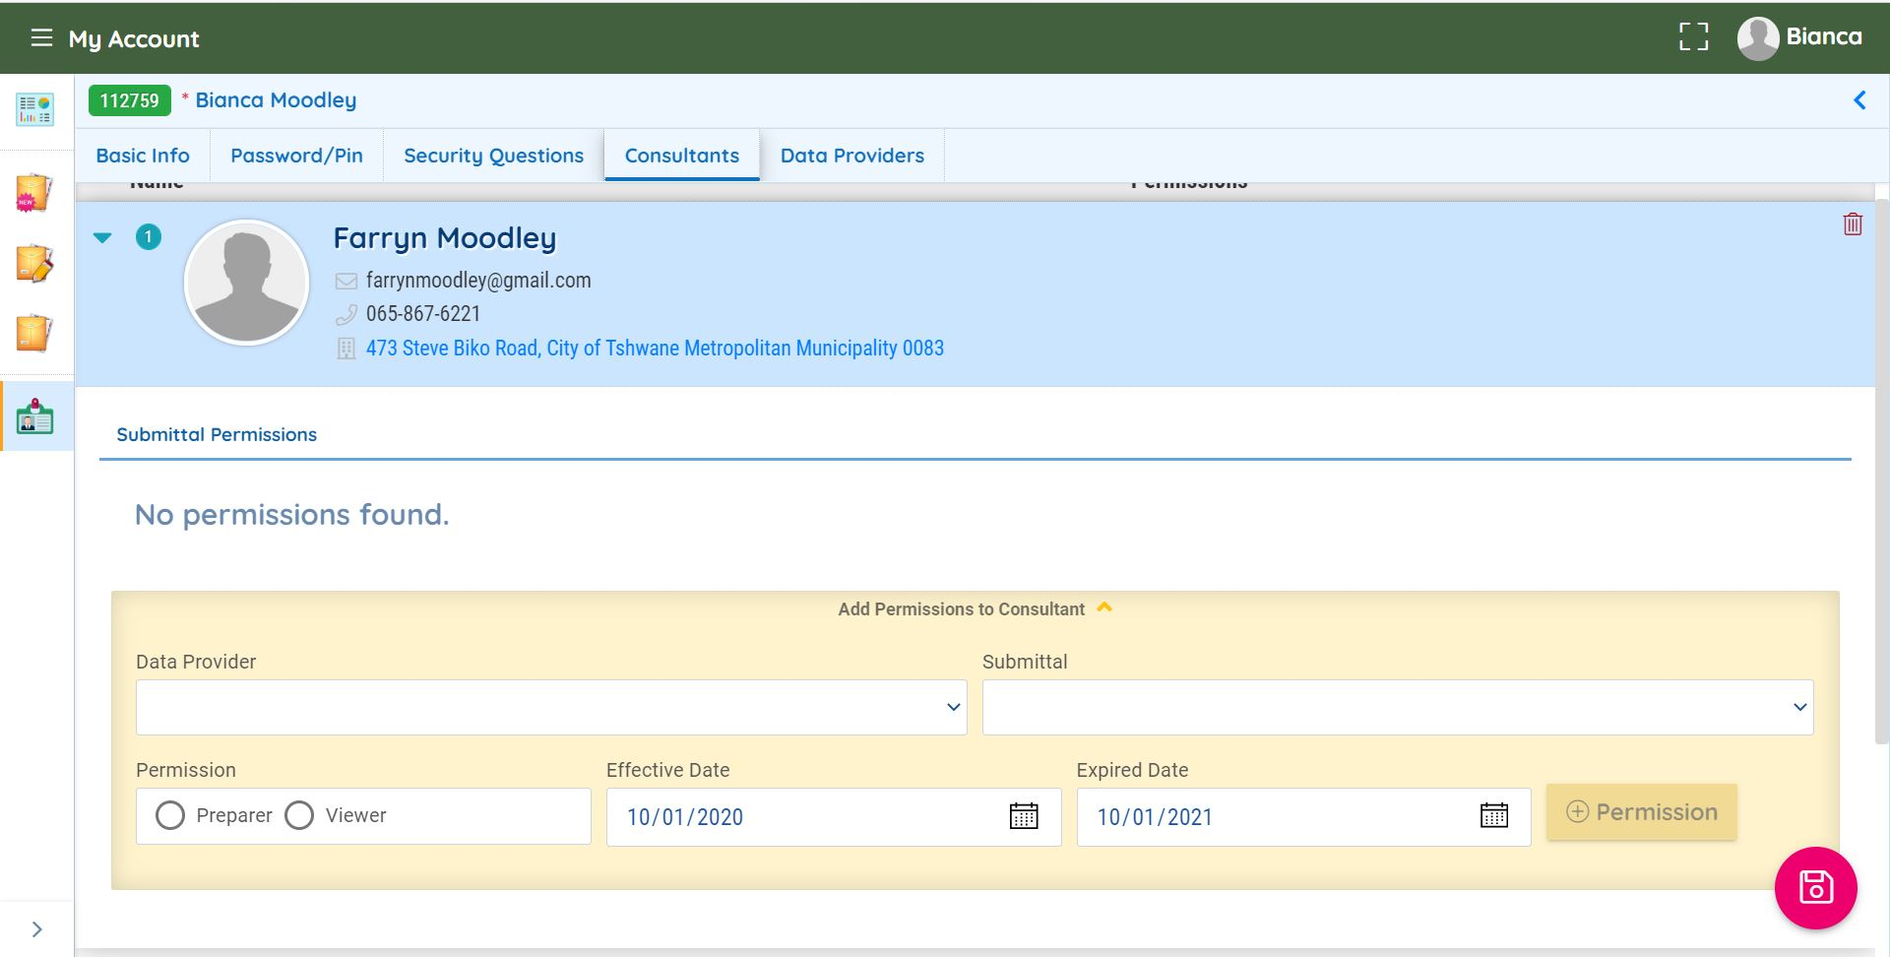

4.4. Circumstances determining the use of country-specific EFs and how this is dealt with inside SAGERS
Technical Guidelines for Monitoring, Reporting, Verification and Validation of Greenhouse Gas Emissions by Industry ( Methodological guidelines for quantification of greenhouse gas emissions) for a particular activity is not appropriate under the specific conditions of greenhouse gas emission, such a data provider may make a submission to the competent authority, by providing the information set out in Annexure 4 of the National Greenhouse gas emission Regulations (NGER), requesting a review of the applicable emission factor.

Select “Request for approval for Country-Specific emission factor”. Please refer to section 5.1 for detailed instructions.
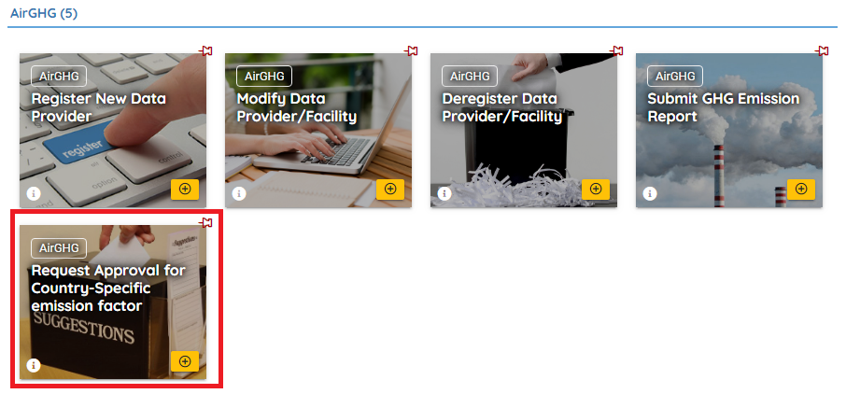
Request Approval for Country-Specific Emission Factor

Prepare and Submit Form
Following sections provide only instructions to the steps that are commonly considered as “difficulty” to first time users.
Step1: Select IPCC codes
Public users need to first provide administrative information and select the IPCC code for which the emission factor applies. On each form, only one IPCC code can be selected.

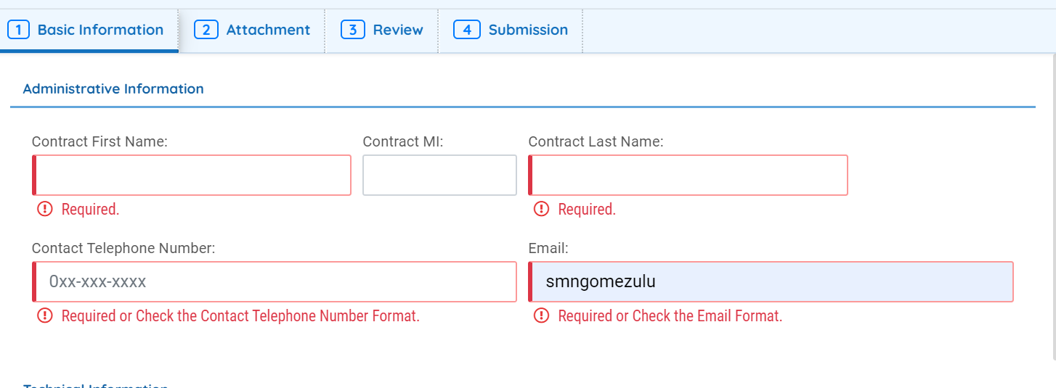

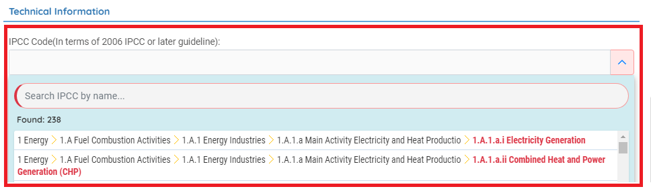
IPCC codes

4.5. How do I convert the country specific net calorific values (NCVs) into the correct units for reporting?
Chapter 47 - Annexure D of the Greenhouse Gas Technical Guidelines provides data providers with country specific net calorific values as well as densities for common fuels used within South Africa. However, the net calorific values need to be converted into a unit that can be used for reporting based on the fuel usage units. An example of this is provided below:
Diesel usage = provided in Tonnes per annum
Diesel emission factor = provided in KGCO₂/TJ
Country Specific Net Calorific Value = Provided in MJ/l
To get the Diesel NCV into a common unit, follow the below steps:
Diesel NCV (TJ/Tonne) = NCV (MJ/l)/ Density (KG/l)
= 38.1 (MJ/l)/ 0.845 (KG/l)
= (45.089 MJ/KG)/ 1000
= 0.045 TJ/Tonne.

Do the different Tier methods change the activity data that data providers need to report?
Using Energy and stationary combustion as an example, activity data will not change for both a Tier 1 and a Tier 2, the only parameter that will be different will be an emission factor (either default - Tier 1; or country specific - Tier 2) but these will use the same activity data.
Tier 3 requires data on fuel combustion, combustion technologies applied together with technology-specific emission factors; and emissions are usually quantified using models and facility level emission data based on a measurement program/mass-balance which tracks carbon flows in and out of the data provider boundary.
The response to this is not the same for all IPCC activities and hence in the guidelines we do provide guidance on the data requirements for Tier 1, Tier 2, and Tier 3.

4.7. What information is required for Tier 3 submissions?

Any Tier 3 submission based on actual measurements must, as a minimum, include information covering the following:
- A background that includes a process description with key process parameters
- Sampling design (where in process, frequency, sampling time, etc.)
- Formal measuring protocol/procedure
- Actual measurements of process parameters and emission
- Calculations sheets
- Quality Control and Quality Assurance (QC/QA)
- GHG Report with final figures (including uncertainty analyses)
Any Tier 3 submission based on mass balance must, as a minimum, include information covering the following:
- A background that includes a process description with key process parameters and carbon streams
- Actual carbon analyses and measurements
- Calculation sheets with final figures
- Quality Control and Quality Assurance (QC/QA)

4.8. When using a Tier 3 method to estimate emissions, will a formal approval of the method used be issued to the data provider?
A confirmation letter will be issued upon approval of a tier 3 methodology used to estimate estimates, however you do not need prior approval to use a tier 3 methodology
DFFE will review the submitted methodology during the normal review process to ensure that the Tier 3 methodology (e.g. material balance) is done in accordance and is consistent with the technical guidance we provide.
It is only when you develop a country-specific emission factor for a Tier 2 method (multiplying production unit by a country-specific/sector or plant-specific emission factor) that we provide a formal prior approval before the use of such an emission factor. Based on this, the confirmation letter provided upon approval of the submission on the SAGERS Portal should be sufficient.

4.9. Do data providers need to use the AR3 to convert to CO_{2eq} instead of the more recent ARs?
When reporting on the SAGERS Portal, the data provider does not need to convert their emissions into CO_{2eq}, as the system calculates the CO_{2eq}. The SAGERS Portal uses the 3rd Assessment Report (AR3).

4.10. When do we use Notation keys when reporting on SAGERS?
Notation keys are used when there are reasons as to why emissions are not estimated for a particular activity. The options under the notation key block and their explanation are presented in the below table:
Table 2: Notation keys
Notation Key Definition | Explanation
Not estimated | Emissions and/removals occur but have not been estimated and reported.
Included elsewhere | Emissions and/or removals are estimated but are not included in the facility under consideration
Not applicable | The activity or category exists but relevant emissions and removals are  considered never to occur.
Not occurring | An activity or process does not exist within a facility.

4.11. Are we able to choose different Tier methods on SAGERS for different fuels when reporting?
No, currently Tier methods are chosen at a greenhouse gas level not a fuel level. However, we are currently communicating with the system developers to allow for the choice to be made at a fuel level.

4.12. Is the GHG Report linked to the registration of the company?
Yes, the GHG Report template is generated based on the registration information for the company, therefore IPCC codes cannot be added to the report once generated in the report, a data provider must initiate a modification submission on the SAGERS in order for additional IPCC activities to reflect on the GHG report template

4.13. Do I still need to report after I have deregistered the Data Provider/ facility during the previous reporting cycle?
A data provider will have to report on the GHG emission from their operation during the time for which the data provider was still eligible to report, prior to the deregistration. For instance, if the data provider was deregistered in July 2021, this data provider will still need to report during the 2022 reporting cycle. The data provider would report on the emissions from January 2021 until June 2021 since the data provider was still operational and eligible for reporting during those months.

4.14. Can I deregister a data provider/facility after an executive decision has been made to no longer operate the plant?
A data provider must notify, in writing, the competent authority of any change in respect of the data provider’s registration details as listed in Annexure 2 of the National Greenhouse Gas (GHG) Emissions Reporting Regulations of 3rd April 2017 within 30 days from the date the data provider became aware of such change occurring.
Data provider/facility should only be deregistered after the plant has officially been decommissioned. If there is some delay between the decision being made and the decommissioning happening, the data provider will still have to report on SAGERS. If the plant is not used during that time, the data provider will report zero throughputs and comments, until the decommissioning has occurred, and the data provider/facility has been deregistered on SAGERS.

4.15. When reporting emissions from the IPPU Sector Metal Industry, do I need to report emissions from secondary production of metals?
You only report emissions for secondary production of metals for the following metals:
- Magnesium Production
- Lead Production
- Zinc Production
Please refer to the Technical Guidelines and the 2006 IPPC Guidelines Volume 3 for further clarity on emission estimation and processes covered.

4.16. When reporting on fugitive emissions from mining, what activity data is expected in the GHG Report when asked for “Amount of coal produced”, does this mean the Run of Mine (ROM) of the coal sold.
The activity data to be provided here is ROM, not the coal that has been sold. ROM is defined as “ore in its natural, unprocessed state”.

5. Technical Questions

Are there any other sequestration guidelines that may be applicable to unmanaged forest land?
The department published the Methodological Guidelines for Quantification of Greenhouse Gas Emissions – Carbon Sequestration in the Forestry Industry. Please note that only managed forest land is eligible to comply. Therefore, natural forests or woodlands are excluded from accounting, but only if they are not managed (managed forests and woodlands are eligible for reporting).

Do the fruit tree plantations fall within the definition of “Forest”, could they be considered Forest land?
Please note the definition of forest below:
“forest” definition from the National Forest Act (Act 84 of 1998) (NFA) states that:
  - “forest” includes a natural forest, a woodland and a plantation (Section 1(2)(x) of NFA).
  - “natural forest” means a group of trees whose crowns are largely contiguous, or which have been declared by the Minister to be a natural forest (Section 1(2)(xx) of NFA).
  - “plantation” means a group of trees cultivated for exploitation of the wood, bark, leaves or essential oils (Section 1(2)(xxii) of NFA).
  - “woodland” means a group of indigenous trees which are not a natural forest, but whose crowns cover more than five percent of the area bounded by the trees forming the perimeter of the group (Section 1(2)(xxxix) of NFA).

Therefore, based on the above definition by the National Forest Act (Act 84 of 1998) (NFA), your fruit tree plantations does not fall within the definition of “Forest”. However, only managed forest are eligible to comply.

Based on the IPCC Guidelines V4_05_Ch5_Cropland, Table 5.4, page 5.10, the citrus fruit plantations falls under the perennial cropland subcategories, and according to the amended National Greenhouse Gas Emission Reporting Regulations the cropland has no threshold and is not required for reporting and for accounting.

Do we report emissions from fires on Temporary unplanted areas?

Fires in standing forests and temporary unplanted areas should be reported and accounted for under ΔC.

If the company exceeds the threshold, but the wastewater treated is inorganic in nature so does not contain carbon and so would not result in GHG emissions then does the company need to register for this activity or not?
The data provider will have to register as a data provider as mandated by the National Greenhouse Gas (GHG) Emissions Reporting Regulations of 3rd April 2017, as amended, since the registration is based on the threshold, i.e. amount of waste treated. The data provider will then have to declare that their wastewater treatment process is not aligned with the treatment processes that are covered by the Technical Guidelines, 2006 IPCC Guidelines and the IPCC 2019 Refinements. Supporting evidence would have to be submitted.

When reporting on the SAGERS system are emissions from mobile combustion (emissions from vehicles) as well as emissions from purchased electricity still excluded from reporting?
Yes, according to the GHG reporting regulations, emissions from mobile combustion (emissions from vehicles) as well as emissions from purchased electricity are excluded from reporting.

Can EPA Method 3C be used for sampling of CO₂ & CH₄ from coal-fired boiler for the purposes of GHG reporting on SAGERS?
Yes, provided that the data provider has done an analysis to check what the difference in emissions would be if you use the default IPCC emission factors vs the emissions calculated using the stack monitoring report. The uncertainty range of measurements must also be provided to allow the competent authority to assess the reliability of the method used.
Minimum of 4 quarterly reports must be used to estimate the emissions to account for seasonal variability as one stack monitoring report is not sufficient to estimate annual emissions.

A foundry produces iron castings, aluminium, zinc, brass and bronze. The aluminium gets melted and casted, they do not add anodes to their process.

Should the foundry register for 2C3 - Aluminium production?
Emissions are not estimated from secondary production of aluminium. As per the 2006 IPCC Guidelines and the 2019 Refinements, emissions of CO₂ and PFCs are released from the primary production smelting undertaken during the Soderberg and Prebake processes.

If 2C3 Aluminium production should be excluded, should we still report on the HFO fuel combusted when melting the Aluminium?
If the capacity of stationary combustion installations used at the foundry equal or exceed the 10 MW(th) threshold as per the GHG Emissions Reporting Regulations, then the data provider will need to register those stationary combustion installations and report on fuel consumption annually.

Does a foundry casting steel, iron, etc. using an induction furnace have to register and report GHG emissions?
The IPCC Guidelines are clear that there is currently no guidance on Induction furnaces as studies done so far show no evidence of appreciable emissions from these types of furnaces. Industries that are operating induction furnaces must declare this to the Competent Authority and this activity will be excluded from registration and reporting.
If the facility is operating induction furnaces but has combustion installations that meet the threshold of 10 MW, the combustion installations must be registered and reported as per requirements on the NGERs.
Example: Company A has an induction furnace onsite but also has 2 coal-fired kilns and 3 three diesel fired standby-generators. All 6 combustion installations are used by the data provider.
The induction furnace does not need to be registered and GHG emissions, from the induction furnace, do not need to be reported as it has been established that the induction furnace is powered by electricity.
However, the additional 5 combustion installations (kilns and standby-generators) run on different fuels. The data provider will then need to calculate the MW(th) of the 5 installations, and should they be equal to or greater than 10 MW(th) (take note of IPCC Category threshold), will need to register and report GHG emissions for these installations annually.
Please refer to question 3.4 above for capacity estimation techniques. Also refer to question 3.3 to explanation on how capacity should be estimated per data provider.

Treatment of emissions from secondary steel production when electric arc furnaces are used.
Steel production can occur at integrated facilities from iron ore, or at secondary facilities, which produce steel mainly from recycled steel scrap. Secondary steelmaking most often occurs in electric arc furnaces (EAFs). Since the EAF process is mainly one of melting scrap and not reducing oxides, CO₂ emissions are associated with the consumption of the carbon electrodes. All carbon used in EAFs should be considered process-related IPPU emissions under IPCC activity 2C1 Iron and Steel Production.
Note: The EAF emission factor within the 2006 IPCC Guidelines relates to scrap metal being the raw material used and not pig-iron.

I am using non- carbonaceous clay with an insignificant carbon content to manufacture bricks do I need to report process emissions?
As per the amended GHG emissions reporting regulations, should the data provider meet the threshold, the data provider will have to register and report GHG emissions via the SAGERS Portal under both IPCC categories 1A2m Brick Manufacturing and 2A4a Ceramics.
Should the data provider use non-carbonaceous clay, lab analysis reports from a SANAS accredited laboratory will need to be attached when reporting under 2A4a and zero emissions are reported. The lab analysis needs to clearly indicate the elements found within the clay.
  - Reporting for carbon capture and storage in the GHG Reporting Programme
Carbon dioxide (CO₂) capture and storage (CCS) involves the capture of CO₂ from anthropogenic sources, its transport to a storage location and its long-term isolation from the atmosphere. SAGERS system is designed in a way that data providers are able to report the amount of carbon captured. At facility level, on the emissions details form there is a field on SAGERS where data providers can input the carbon captured for each IPCC code registered. The amount of carbon captured needs to be reported under the category in which it was generated.
For example, if the carbon was captured from 1A1c, the data provider must report emissions generated from 1A1c and also report the amount of carbon captured from 1A1c.

Recycled oil is used in our production process, what calorific value and emission factors should be used when reporting on this fuel?
The data provider should use the calorific value (and density if required) that is provided by the supplier of the recycled oil. The data provider should also seek guidance from the supplier regarding the composition of the recycled oil as well as a proxy fuel (found on the SAGERS fuel list) that can be used that is the closest approximation to the recycled oil (in terms of physical and chemical properties). This proxy fuel’s emission factors can then be used to estimate emissions from the use of the recycled oil.
Supporting evidence of how the proxy fuel was arrived at must be submitted with each report. Examples of supporting evidence include, but are not limited to, a lab analysis, from a SANAS accredited laboratory, that shows that the properties of the recycled oil are close/similar to that of the proxy fuel or any theoretical analysis done to conclude that the recycled oil resembles the proxy fuel chosen

We I received analyses for my coal from a laboratory. Which value should I use for the NCV: “As Received”, “Air Dried” or “Dried”?
The NCV is the energy that is left in the raw material once all water has been removed and which is actually available for any process. Hence the value for “Dried” should be used.

Which value must be used for NCV: higher heating value (or Gross Calorific Value - GCV) or lower heating value (or Net Calorific Value - NCV)?
The higher heating value includes the energy required to vapourise water that is also in the raw material. The lower heating value is the energy that is left in the raw material once all water has been removed and which is actually available for any process. Hence the Lower Heating Value (NCV), must be used.

A client of ours burns waste tyres as part of the production process. From the National Treasury Budget 2021, we gather that this is exempt from carbon tax for this year as there are no emission factors available (see attached on page 151).
Could you please clarify your position on this in relation to the NGER? In other words, does it need to be reported on?
The GHG emissions from waste tyre combustion should still be reported on SAGERS. SAGERS currently has Tier 1 emission factors for tyres and hence the emissions can be estimated. The data provider would have to provide a supplier specific calorific value as SAGERS currently does not have a default or country specific calorific value for waste tyres.

  - There are a few companies who need to start using Tier 2 or Tier 3 methods to determine their emissions next year. With this in mind, is there any guidance as to what would be acceptable as a Tier 2 emission factor? For example, if they needed a Tier 2 emission factor for coal, would it be acceptable for them to base this emission factor on some combustion tests done on the coal in the lab? If so, then how many tests would be required etc.? What would be acceptable to DFFE?
Any emission factor that is not already on the SAGERS should undergo an approval process before it can be used.
Before a tier 2 emissions factor can be used, there is an approved process that must be followed in order to establish the specific emissions factor. This process can differ between processes and products. A methodology must be presented to the DFFE for establishment of this factor beforehand.
Note that, should the supplier of a product be able to give a verified emission factor, DFFE will verify the emission factor, then it can also be used.

Will the SA Emission Factors be published in time for the March 2023 GHG reporting cycle? Or can I assume that we’ll need to use Tier 3, mass balance, etc. methods where “Tier 2 or 3” is stipulated in the Regulations?
Not all Tier 2 emission factors will be available before March 2023. Should they not be available, a Tier 3 methodology should be used. Note that, should the supplier of a product be able to give a verified emission factor, then it can also be used, provided that it is approved by DFFE. The supplier must submit a country specific request submission to DFFE for approval via SAGERS.
Should a Tier 3 methodology be used, it must be an approved methodology or mass balance. Supporting evidence of how the emissions were estimated must be attached to the GHG report on SAGERS.

Can I report my GHG emissions using the 2019 IPCC Refinements?
The 2019 IPCC Refinements should not be used for now. They should only be used as and when they are reflected in the New Methodological Guidelines that will be published in due course.

Emissions from Fishing Vessels
A data provider that owns and operates fishing vessels should register for either IPCC code 1A3di for international water-borne navigation or IPCC code 1A3dii for domestic water-borne navigation, depending on which code applies and if the threshold of 100 000 litres /year of fuel is used.

